Essential Foundations of Economics, 8e (Bade)
Chapter 1 Getting Started

1.1 Definition and Questions

1) Scarcity exists because
A) human wants exceed the resources available to satisfy them.
B) some individuals have low income.
C) the costs of production are high.
D) some people make bad economic decisions.
E) people take too much leisure time.
Answer: A
Topic: Scarcity
Skill: Level 1: Definition
Section: Checkpoint 1.1
Status: Old
AACSB: Reflective thinking

2) Scarcity
A) is the inability to satisfy all our wants.
B) leads to higher prices.
C) applies only to people living in poverty.
D) is not something that affects very rich people.
E) used to exist everywhere but has been eliminated in advanced economies.
Answer: A
Topic: Scarcity
Skill: Level 1: Definition
Section: Checkpoint 1.1
Status: Old
AACSB: Reflective thinking

3) Scarcity requires that we
A) produce efficiently.
B) learn to limit our wants.
C) have the most rapid economic growth possible.
D) have unlimited resources.
E) make choices about what goods and services to produce.
Answer: E
Topic: Scarcity
Skill: Level 1: Definition
Section: Checkpoint 1.1
Status: Old
AACSB: Reflective thinking
4) Scarcity means that
A) what we can produce with our resources is greater than our material wants.
B) resources are unlimited.
C) wants are greater than what we can produce with our resources.
D) governments must make up for shortages in resources.
E) choices made in self-interest cannot be the same as those made in the social interest.
Answer: C
Topic: Scarcity
Skill: Level 1: Definition
Section: Checkpoint 1.1
Status: Revised
AACSB: Reflective thinking

5) Because human wants are insatiable and unlimited while available resources are limited, people are said to face the problem of
A) scarcity.
B) why to produce.
C) macroeconomics.
D) microeconomics.
E) social interest versus self-interest.
Answer: A
Topic: Scarcity
Skill: Level 1: Definition
Section: Checkpoint 1.1
Status: Old
AACSB: Reflective thinking

6) Which of the following statements best describes the study of economics? Economics studies how
A) to organize production so that scarcity does not occur.
B) firms make profits.
C) we make choices in the face of scarcity.
D) to create incentives so that scarcity does not exist.
E) businesses reach decisions.
Answer: C
Topic: Scarcity
Skill: Level 1: Definition
Section: Checkpoint 1.1
Status: Old
AACSB: Reflective thinking

7) Scarcity forces people to
A) choose among available alternatives.
B) cheat and steal.
C) be unwilling to help others.
D) live at a low standard of living.
E) consume as much as they can as quickly as they can.
Answer: A
Topic: Scarcity
Skill: Level 2: Using definitions
Section: Checkpoint 1.1
Status: Old
AACSB: Reflective thinking
8) Scarcity means we must
A) consume less.
B) produce less.
C) make choices.
D) earn more.
E) work more.
Answer: C
Topic: Scarcity
Skill: Level 1: Definition
Section: Checkpoint 1.1
Status: Old
AACSB: Reflective thinking

9) What is the reason that all economic issues and problems occur?
A) All nations use some form of money to buy and sell goods and services.
B) Humans are always wasteful and inefficient in production and consumption.
C) Powerful governments are able to control production and consumption.
D) Human wants exceed the resources available to satisfy them.
E) People seek only their own self-interest.
Answer: D
Topic: Scarcity
Skill: Level 2: Using definitions
Section: Checkpoint 1.1
Status: Old
AACSB: Reflective thinking

10) The study of economics is best described as a study of
A) the factors that influence the stock and bond markets.
B) capitalism.
C) the choices made in producing goods and services.
D) coping with scarcity, and choices made as a result of scarcity in a society.
E) how people earn a living.
Answer: D
Topic: Definition of economics
Skill: Level 1: Definition
Section: Checkpoint 1.1
Status: Old
AACSB: Reflective thinking

11) Which of the following statements best describes the study of economics? Economics studies how
A) to organize production so that scarcity does not occur.
B) firms make profits.
C) we make choices in the face of scarcity.
D) to create incentives so that scarcity does not exist.
E) businesses reach decisions.
Answer: C
Topic: Definition of economics
Skill: Level 1: Definition
Section: Checkpoint 1.1
Status: Old
AACSB: Reflective thinking
12) Which of the following best defines economics?
A) Economics teaches how to limit our wants.
B) Economics studies how to choose the best alternative when coping with scarcity.
C) Economics helps you earn as much money as possible.
D) Economics analyzes all aspects of human behavior in general.
E) Economics is concerned with prices and quantities of goods and services, both at the individual level and at the industry level.
Answer: B
Topic: Definition of economics
Skill: Level 1: Definition
Section: Checkpoint 1.1
Status: Old
AACSB: Reflective thinking

13) Economics is the social science that studies
A) the real reasons people buy goods and services.
B) the psychology of individuals and businesses.
C) whether a nation has enough natural resources.
D) how people make choices to cope with scarcity.
E) how choices made in the social interest could eliminate scarcity.
Answer: D
Topic: Definition of economics
Skill: Level 1: Definition
Section: Checkpoint 1.1
Status: Old
AACSB: Reflective thinking

14) Economics is best defined as the social science that studies
A) how a person can get everything he or she wants.
B) the reason money exists.
C) the way to eliminate choices in our decisions.
D) the choices that societies, and the people and institutions that make up societies, make in dealing with the issue of scarcity.
E) how choices made in the social interest must conflict with choices made in the self-interest.
Answer: D
Topic: Definition of economics
Skill: Level 1: Definition
Section: Checkpoint 1.1
Status: Old
AACSB: Reflective thinking
15) Microeconomics includes the study of the
A) aggregate effects on the national economy.
B) recessions and inflation in the global economy.
C) choices made by individuals and businesses.
D) reasons why the government changes interest rates.
E) nationwide unemployment rate.
Answer: C
Topic: Microeconomics
Skill: Level 1: Definition
Section: Checkpoint 1.1
Status: Old
AACSB: Reflective thinking

16) The primary focus of microeconomics is
A) to examine the operation of the entire (aggregate) economy.
B) to examine the behavior and operation of the individual units or sectors that make up the economy.
C) our government's monetary policy.
D) the levels of employment and inflation.
E) to study how we managed to eliminate scarcity.
Answer: B
Topic: Microeconomics
Skill: Level 1: Definition
Section: Checkpoint 1.1
Status: Old
AACSB: Reflective thinking

17) Which of the following is a microeconomic issue?
A) The price of gasoline increases in the United States this year.
B) The Brazilian economy experiences rapid economic growth.
C) The unemployment rate soars in Spain.
D) Inflation skyrockets in Russia.
E) The U.S. government cuts taxes to combat a recession.
Answer: A
Topic: Microeconomics
Skill: Level 2: Using definitions
Section: Checkpoint 1.1
Status: Old
AACSB: Reflective thinking

18) Which of the following is a microeconomic issue?
A) Growth in the U.S. economy slowed.
B) Increased federal government expenditures have lowered the unemployment rate.
C) The inflation rate fell this year.
D) The quantity of wheat grown in the United States increases this year.
E) The U.S. government cuts taxes to combat a recession.
Answer: D
Topic: Microeconomics
Skill: Level 2: Using definitions
Section: Checkpoint 1.1
Status: Old
AACSB: Reflective thinking
19) Which of the following is a microeconomic topic?
i. K-Mart's decision to close stores that are not making a profit
ii. Home Depot's choice to hire more full-time employees because its sales increased
iii. Delta Airlines changes its fares.
A) i only
B) ii only
C) i and iii
D) ii and iii
E) i, ii, and iii
Answer: E
Topic: Microeconomics
Skill: Level 2: Using definitions
Section: Checkpoint 1.1
Status: Old
AACSB: Reflective thinking

20) Which of the following is a microeconomic topic?
A) Northwest Airlines analyzes the benefits of adding one more flight to Salt Lake City.
B) Unemployment soars as taxes increase.
C) The government leaves interest rates unchanged as the economy improves.
D) Germany's government increases taxes to avoid a budget deficit.
E) Chinese economic growth slows.
Answer: A
Topic: Microeconomics
Skill: Level 2: Using definitions
Section: Checkpoint 1.1
Status: Old
AACSB: Reflective thinking

21) Which of the following is a microeconomic topic?
i. Gas prices increase after a hurricane hits the gulf coast.
ii. Xavier starts a new business designing web pages.
iii. Abby decides to practice an extra hour of soccer instead of studying.
A) i, ii and iii
B) i only
C) ii and iii
D) ii only
E) i and ii
Answer: A
Topic: Microeconomics
Skill: Level 2: Using definitions
Section: Checkpoint 1.1
Status: Old
AACSB: Reflective thinking
22) Macroeconomics is the study of
A) the actions of individual consumers.
B) national or global economies.
C) the actions of individual businesses.
D) the government.
E) how ceteris paribus affects causation.
Answer: B
Topic: Macroeconomics
Skill: Level 1: Definition
Section: Checkpoint 1.1
Status: Old
AACSB: Reflective thinking

23) Which of the following BEST describes macroeconomics?
A) It analyzes the aggregate effects on the national economy of the choices made by individuals, firms, and governments.
B) It studies the choices that individuals and businesses make when coping with scarcity.
C) It examines how the choices that individuals affect governments.
D) It is not a social science because its predictions cannot be tested.
E) Proving causation is never a problem for macroeconomics.
Answer: A
Topic: Macroeconomics
Skill: Level 1: Definition
Section: Checkpoint 1.1
Status: Old
AACSB: Reflective thinking

24) Which of the following is a topic studied in macroeconomics?
A) the pricing decisions in the computer hardware industry
B) the effect on economic growth if the government raises taxes
C) how the wheat industry determines how much wheat to grow
D) the impact of labor unions on wages
E) the impact of higher prices for gasoline on the number of SUVs people buy
Answer: B
Topic: Macroeconomics
Skill: Level 2: Using definitions
Section: Checkpoint 1.1
Status: Old
AACSB: Reflective thinking

25) Which of the following is a macroeconomic topic?
A) The federal government's decision to spend more on environmental protection
B) The county government's decision to increase the sales tax for your county
C) Why did production and jobs expand slowly in 2011?
D) General Motors decides what prices to set for their new models.
E) The effect of floods in agricultural areas on the price and quantity of wheat
Answer: C
Topic: Macroeconomics
Skill: Level 2: Using definitions
Section: Checkpoint 1.1
Status: Revised
AACSB: Reflective thinking
26) Which of the following is a macroeconomic issue?
A) The price of a ticket to Walt Disney World in Orlando is increased.
B) The National Football League signs a new television contract.
C) The number of jobs and production in Zimbabwe increase.
D) The Iowa corn harvest is smaller than normal.
E) Utilities are required to install more anti-pollution devices.
Answer: C
Topic: Macroeconomics
Skill: Level 2: Using definitions
Section: Checkpoint 1.1
Status: Old
AACSB: Reflective thinking

27) Which of the following is a macroeconomic topic?
i. China increases interest rates to slow its economic growth.
ii. Congress lowers tax rates to try and lower the unemployment rate.
iii. Nissan decides to produce more electric Leaf models and fewer Altima sedans.
A) i and ii
B) i, ii and iii
C) iii only
D) i and iii
E) ii and iii
Answer: A
Topic: Macroeconomics
Skill: Level 2: Using definitions
Section: Checkpoint 1.1
Status: Old
AACSB: Reflective thinking

28) When you make the decision to spend your time attending class, which economic question are you answering?
A) What?
B) How?
C) For whom?
D) Why?
E) Is this in the social interest?
Answer: A
Topic: Economic questions, what
Skill: Level 2: Using definitions
Section: Checkpoint 1.1
Status: Old
AACSB: Reflective thinking
29) Which of the following is the best example of a "What?" question?
A) Should automobiles be produced using workers or robots?
B) Should higher-income or lower-income people buy SUVs?
C) Should we make faster microprocessors or pest-resistant corn?
D) Should migrant workers or domestic workers be used to pick grapes?
E) What should doctors be paid?
Answer: C
Topic: Economic questions, what
Skill: Level 2: Using definitions
Section: Checkpoint 1.1
Status: Old
AACSB: Reflective thinking

30) When Ford decides to increase production of hybrid cars, it directly answers the ________ question.
A) what
B) how
C) for whom
D) where
E) why
Answer: A
Topic: Economic questions, what
Skill: Level 2: Using definitions
Section: Checkpoint 1.1
Status: Old
AACSB: Reflective thinking

31) When Delta decides to quit flying to Lithuania, it directly answers the ________ question.
A) what
B) why
C) for whom
D) how
E) when
Answer: A
Topic: Economic questions, what
Skill: Level 2: Using definitions
Section: Checkpoint 1.1
Status: Old
AACSB: Reflective thinking
32) The question of "What goods and services get produced?" most closely relates to which of the following issues?
A) the distribution of goods and services in the economy
B) producing goods and services in the least costly manner
C) building a missile defense system, or putting a computer in every elementary school classroom
D) obtaining specialized training to increase one's income
E) taxing high income workers to give payments to poor households
Answer: C
Topic: Economic questions, what
Skill: Level 3: Using models
Section: Checkpoint 1.1
Status: Old
AACSB: Reflective thinking

33) When a home builder decides to computerize all of its production schedule, it directly answers the ________ question.
A) for whom
B) what
C) where
D) how
E) why
Answer: D
Topic: Economic questions, how
Skill: Level 2: Using definitions
Section: Checkpoint 1.1
Status: Old
AACSB: Reflective thinking

34) When Fresh Express Salads decides to mechanically pick all of its lettuce, it directly answers the ________ question.
A) what
B) how
C) for whom
D) where
E) when
Answer: B
Topic: Economic questions, how
Skill: Level 2: Using definitions
Section: Checkpoint 1.1
Status: Old
AACSB: Reflective thinking
35) When the power company decides to use manpower to bury its lines, it directly answers the ________ question.
A) what
B) for whom
C) how
D) why
E) when
Answer: C
Topic: Economic questions, how
Skill: Level 2: Using definitions
Section: Checkpoint 1.1
Status: Old
AACSB: Reflective thinking

36) The question of "How are goods and services produced?" most closely addresses which of the following issues?
A) Should Ford build SUVs or luxury cars?
B) Should Ford use expensive industrial robots or inexpensive Mexican autoworkers to produce SUVs?
C) Should contractors build residential housing or shopping malls?
D) Is income distributed fairly in the United States?
E) Why are Christmas trees popular only in December?
Answer: B
Topic: Economic questions, how
Skill: Level 2: Using definitions
Section: Checkpoint 1.1
Status: Revised
AACSB: Reflective thinking

37) Of the three major economic questions, which of the following is the best example of a "How?" question?
A) Should we produce more heavy fleece coats?
B) Should we collect tolls on turnpikes using human toll collectors or mechanized toll machines?
C) Should we build log homes or build factories from bricks?
D) Should we spend more on health care?
E) Should we eat more oatmeal?
Answer: B
Topic: Economic questions, how
Skill: Level 2: Using definitions
Section: Checkpoint 1.1
Status: Old
AACSB: Reflective thinking
38) Which economic question depends on the incomes that people earn and the prices they pay for goods and services?
A) What?
B) How?
C) For whom?
D) Why?
E) Where?
Answer: C
Topic: Economic questions, for whom
Skill: Level 1: Definition
Section: Checkpoint 1.1
Status: Old
AACSB: Reflective thinking

39) When the federal government decides to pay senators more than it pays soldiers, it answers the ________ question.
A) why
B) how
C) for whom
D) what
E) where
Answer: C
Topic: Economic questions, for whom
Skill: Level 2: Using definitions
Section: Checkpoint 1.1
Status: Old
AACSB: Reflective thinking

40) When a third string NFL quarterback earns more than a police officer, society answers the ________ question.
A) for whom
B) what
C) how
D) why
E) social interest vs. self-interest
Answer: A
Topic: Economic questions, for whom
Skill: Level 2: Using definitions
Section: Checkpoint 1.1
Status: Old
AACSB: Reflective thinking
41) When unskilled teens earn less than college graduates, society answers the ________ question.
A) how
B) what
C) for whom
D) why
E) social interest versus self-interest
Answer: C
Topic: Economic questions, for whom
Skill: Level 2: Using definitions
Section: Checkpoint 1.1
Status: Old
AACSB: Reflective thinking

42) Canada has nationalized health care, so that everyone, regardless of their ability to pay, has some access to health care. Based on this observation, Canada has decided that "everyone, regardless of their ability to pay" is the answer to what microeconomic question?
A) What type of health care will be produced and in what quantity?
B) How will health care be produced?
C) For whom will health care be produced?
D) Why will we offer health care?
E) Must we offer health care?
Answer: C
Topic: Economic questions, for whom
Skill: Level 3: Using models
Section: Checkpoint 1.1
Status: Old
AACSB: Analytical thinking

43) Choices that are best for the individuals that make them are choices in pursuit of
A) the social interest.
B) efficiency.
C) incentives.
D) self-interest.
E) equity.
Answer: D
Topic: Self interest
Skill: Level 1: Definition
Section: Checkpoint 1.1
Status: Old
AACSB: Reflective thinking

44) Self-interest
A) reflects choices that are best for society as a whole.
B) reflects choices that are best for the individual who makes them.
C) has nothing to do with determining what goods are produced.
D) occurs only when wants exceed available resources.
E) cannot be used to determine how goods are produced.
Answer: B
Topic: Self interest
Skill: Level 1: Definition
Section: Checkpoint 1.1
Status: Old
AACSB: Reflective thinking
45) Choices that are best for the society as a whole are choices in pursuit of
A) answering the "how" question.
B) the social interest.
C) self-interest.
D) incentives.
E) answering the "for whom" question.
Answer: B
Topic: Social interest
Skill: Level 1: Definition
Section: Checkpoint 1.1
Status: Old
AACSB: Reflective thinking

46) The characteristic from which all economic problems arise is
A) political decisions.
B) providing a minimal standard of living for every person.
C) how to make a profit.
D) hunger.
E) scarcity.
Answer: E
Topic: Scarcity
Skill: Level 2: Using definitions
Section: Checkpoint 1.1
Status: Old
AACSB: Reflective thinking

47) All economic questions and problems arise from
A) the fact that society has more than it needs.
B) turmoil in the stock market.
C) the unequal distribution of income.
D) a society's wants exceeding what its scarce resources can produce.
E) the difference between self-interest and social interest.
Answer: D
Topic: Scarcity
Skill: Level 1: Definition
Section: Checkpoint 1.1
Status: Old
AACSB: Reflective thinking

48) Scarcity results from the fact that
A) people's wants exceed the resources available to satisfy them.
B) not all goals are desirable.
C) we cannot answer the major economic questions.
D) choices made in self-interest are not always in the social interest.
E) the population keeps growing.
Answer: A
Topic: Scarcity
Skill: Level 1: Definition
Section: Checkpoint 1.1
Status: Revised
AACSB: Reflective thinking
49) To economists, scarcity means that
A) limited wants cannot be satisfied by the unlimited resources.
B) a person looking for work is not able to find work.
C) the number of people without jobs rises when economic times are bad.
D) there can never be answers to the what, how or for whom questions.
E) unlimited wants cannot be satisfied by the limited resources.
Answer: E
Topic: Scarcity
Skill: Level 1: Definition
Section: Checkpoint 1.1
Status: Old
AACSB: Reflective thinking

50) Which of the following statements is true regarding scarcity?
A) Scarcity affects poorer countries only.
B) An economy experiences scarcity only when the incomes of its citizens decline.
C) Poor people experience scarcity more often than do rich people.
D) All citizens in a wealthy economy experience scarcity.
E) Scarcity could be overcome if people would make all choices in the social interest.
Answer: D
Topic: Scarcity
Skill: Level 2: Using definitions
Section: Checkpoint 1.1
Status: Old
AACSB: Reflective thinking

51) People must make choices because
A) most people enjoy shopping.
B) of scarcity.
C) there are many goods available.
D) the question "What goods and services are produced?" is not adequately answered.
E) making choices is in the social interest.
Answer: B
Topic: Scarcity
Skill: Level 2: Using definitions
Section: Checkpoint 1.1
Status: Old
AACSB: Reflective thinking

52) Which of the following is a microeconomic issue?
A) Why has unemployment risen nationwide?
B) Why has economic growth been rapid in China?
C) What is the impact on the quantity of Pepsi purchased if consumers' tastes change in favor of non-carbonated drinks?
D) Why is the average income lower in Africa than in Latin America?
E) Why did overall production increase within the United States last year?
Answer: C
Topic: Microeconomics
Skill: Level 1: Definition
Section: Checkpoint 1.1
Status: Old
AACSB: Reflective thinking
53) Microeconomics includes the study of
A) how countries decide to fund their budget deficits.
B) the choices that individuals and businesses make.
C) how a nation promotes economic growth.
D) the effect on the national economy of the choices that individuals make.
E) the overall amount of production within the economy.
Answer: B
Topic: Microeconomics
Skill: Level 1: Definition
Section: Checkpoint 1.1
Status: Old
AACSB: Reflective thinking

54) The question "Should we produce LCD televisions or computer monitors?" is an example of a ________ question.
A) what
B) how
C) for whom
D) where
E) why
Answer: A
Topic: Economic questions, what
Skill: Level 2: Using definitions
Section: Checkpoint 1.1
Status: Old
AACSB: Reflective thinking

55) When Ferrari decides to produce 1,200 360 Modenas each year, Ferrari is answering the ________ question.
A) for whom
B) how
C) what
D) why
E) scarcity
Answer: C
Topic: Economic questions, what
Skill: Level 2: Using definitions
Section: Checkpoint 1.1
Status: Old
AACSB: Reflective thinking
56) Whether a company produces fishing rods mostly by hand or using high-tech machinery is a question of
A) "For whom will goods be produced?"
B) "When will the goods be produced?"
C) "Where will the goods be produced?"
D) "How will the goods be produced?"
E) "Why will the goods be produced?"
Answer: D
Topic: Economic questions, how
Skill: Level 2: Using definitions
Section: Checkpoint 1.1
Status: Old
AACSB: Reflective thinking

57) When a landscaping company decides to use drafting software and computers instead of hiring designers to draw design plans by hand, it is answering the ________ question.
A) how
B) what
C) for whom
D) opportunity cost
E) why
Answer: A
Topic: Economic questions, how
Skill: Level 2: Using definitions
Section: Checkpoint 1.1
Status: Old
AACSB: Reflective thinking

58) The question "Should we produce houses using bricks or wood?" is an example of a ________ question.
A) what
B) how
C) for whom
D) where
E) why
Answer: B
Topic: Economic questions, how
Skill: Level 2: Using definitions
Section: Checkpoint 1.1
Status: Old
AACSB: Reflective thinking
59) The question "Should economics majors or sociology majors earn more after they graduate?" is an example of a ________ question.
A) what
B) how
C) for whom
D) where
E) why
Answer: C
Topic: Economic questions, for whom
Skill: Level 2: Using definitions
Section: Checkpoint 1.1
Status: Old
AACSB: Reflective thinking

60) If a decision is made and it is the best choice for society, the decision is said to be
A) a valid economic choice.
B) made in self-interest.
C) made in social interest.
D) consist with scarcity.
E) a want-maximizing choice.
Answer: C
Topic: Social interest
Skill: Level 2: Using definitions
Section: Checkpoint 1.1
Status: Old
AACSB: Reflective thinking

1.2 The Economic Way of Thinking

1) Rational choice
A) is a choice that uses the available resources to best achieve the objective of the person making the choice.
B) is always efficient.
C) is what you must give up to get what you want.
D) is made by comparing different incentives.
E) provides the answer to only the "how" question.
Answer: A
Topic: Rational choice
Skill: Level 1: Definition
Section: Checkpoint 1.2
Status: Old
AACSB: Reflective thinking
2) A rational choice is one that
A) always turns out for the best for the decision maker.
B) creates no costs for the decision maker.
C) must be made with perfect information.
D) uses the available resources to most effectively satisfy the wants of the person making the choice.
E) is made in the social interest rather than the self-interest.
Answer: D
Topic: Rational choice
Skill: Level 1: Definition
Section: Checkpoint 1.2
Status: Old
AACSB: Reflective thinking

3) What is NOT true about rational choice?
A) It can result in different decisions for different individuals.
B) It involves comparing costs and benefits.
C) It might turn out not to have been the best choice after the event.
D) It is a choice that uses the available resources to best achieve the objective of the person making the choice.
E) It is the same for all individuals.
Answer: E
Topic: Rational choice
Skill: Level 1: Definition
Section: Checkpoint 1.2
Status: Old
AACSB: Reflective thinking

4) In economics, cost is measured as ________, and benefit is measured as ________.
A) what you must give up to get something; what you are willing to give up to get it
B) what you are willing to give up to get it; what you must give up to get something
C) the amount of money that you pay for something; the amount of money that someone else is willing to pay you
D) what you are willing to pay on the margin; what the government pays you when you are unemployed or retired
E) the amount of money that you pay on the margin; the amount of money that you receive on the margin
Answer: A
Topic: Benefits and costs
Skill: Level 1: Definition
Section: Checkpoint 1.2
Status: Old
AACSB: Reflective thinking
5) An opportunity cost is
A) the dollar amount that is paid.
B) anything the decision maker believes costs to be.
C) the benefits of the highest-valued alternative forgone.
D) whatever is paid out and cannot be reduced or reversed.
E) another term for all the sunk costs.
Answer: C
Topic: Opportunity cost
Skill: Level 1: Definition
Section: Checkpoint 1.2
Status: Old
AACSB: Reflective thinking

6) Economists measure opportunity cost
A) only when it is on the margin.
B) as the best thing given up.
C) as the sum of all forgone opportunities.
D) as the same as marginal benefit.
E) as equal to the sum of all the sunk costs.
Answer: B
Topic: Opportunity cost
Skill: Level 1: Definition
Section: Checkpoint 1.2
Status: Old
AACSB: Reflective thinking

7) The opportunity cost of a decision is measured in terms of
A) time.
B) the price of the alternative we choose.
C) the next best thing given up.
D) the price of a new opportunity that arises.
E) sunk cost.
Answer: C
Topic: Opportunity cost
Skill: Level 2: Using definitions
Section: Checkpoint 1.2
Status: Old
AACSB: Reflective thinking
8) You have chosen to take a trip during spring break. If you had not gone, you would either have worked at a temporary job or studied for exams. The opportunity cost of your trip is
A) the wages you would have earned from working.
B) the lower grade earned by not studying.
C) the wages you would have earned from working and the lower grade earned by not studying.
D) the value of the trip.
E) We cannot determine what the opportunity cost is without knowing which alternative, working or studying, you would have preferred.
Answer: E
Topic: Opportunity cost
Skill: Level 2: Using definitions
Section: Checkpoint 1.2
Status: Old
AACSB: Reflective thinking

9) If Jessie studies economics for two hours instead of going to the movies with her friends, then
A) the benefit of studying is the missed movie.
B) the opportunity cost of studying is the missed movie.
C) Jesse definitely is making a rational choice.
D) Jessie is ignoring a sunk cost.
E) Jessie is not responding to any incentives.
Answer: B
Topic: Making rational choices
Skill: Level 2: Using definitions
Section: Checkpoint 1.2
Status: Old
AACSB: Reflective thinking

10) The value of the best thing that a person must give up when making a decision is known as the ________ cost.
A) direct
B) benefit's
C) opportunity
D) explicit
E) sunk
Answer: C
Topic: Opportunity cost
Skill: Level 1: Definition
Section: Checkpoint 1.2
Status: Old
AACSB: Reflective thinking
11) Ali decides to attend the one-hour review session for microeconomics instead of working at his job. His job pays him $10 per hour. Ali's opportunity cost of attending the review session is
A) the $10 he could have earned at his job.
B) the value of the session minus the $10 he could have earned at his job.
C) nothing, because the review session does not cost anything.
D) equal to the benefit he gets from the review session.
E) the one-hour review session.
Answer: A
Topic: Opportunity cost
Skill: Level 2: Using definitions
Section: Checkpoint 1.2
Status: Old
AACSB: Analytical thinking

12) Suppose that, instead of taking this test, you could either have worked and earned income or partied and had a pleasurable time. Your opportunity cost of taking the test is the
A) forgone work.
B) forgone party.
C) forgone working and partying.
D) forgone working or partying, depending on which was your next best choice.
E) test because you are taking it.
Answer: D
Topic: Opportunity cost
Skill: Level 2: Using definitions
Section: Checkpoint 1.2
Status: Old
AACSB: Reflective thinking

13) The benefit from a good or service that you purchase is measured by
A) the dollar amount that is paid for the good or service.
B) the dollar amount you can get by selling the good or service.
C) what you are willing to give up to obtain the good or service.
D) how strong the incentives were that lead to buying the good or service.
E) None of the above answers is correct because there is no way to measure the benefit you receive from purchasing a good or service.
Answer: C
Topic: Benefit
Skill: Level 1: Definition
Section: Checkpoint 1.2
Status: Old
AACSB: Reflective thinking
14) Suppose you take a trip during spring break. To determine the benefit of taking the trip, you
A) calculate the opportunity cost of the trip.
B) measure what you are willing to give up to take the trip.
C) determine the sunk cost of taking the trip.
D) calculate the value of the next best alternative foregone.
E) must measure what the trip is worth to you and then subtract the cost of the trip.
Answer: B
Topic: Benefit
Skill: Level 1: Definition
Section: Checkpoint 1.2
Status: Old
AACSB: Reflective thinking

15) The cost of a one-unit increase in an activity is called the
A) opportunity benefit.
B) rational cost.
C) marginal cost.
D) marginal benefit.
E) margin.
Answer: C
Topic: Marginal cost
Skill: Level 1: Definition
Section: Checkpoint 1.2
Status: Old
AACSB: Reflective thinking

16) The opportunity cost of a one-unit increase in an activity
A) is greater than the marginal benefit.
B) is called rational cost.
C) decreases as you do more of it.
D) is called marginal cost.
E) is measured by what the person is willing to give up to get one more unit of the activity.
Answer: D
Topic: Marginal cost
Skill: Level 1: Definition
Section: Checkpoint 1.2
Status: Old
AACSB: Reflective thinking

17) Mothers Against Drunk Drivers (MADD) campaigned to increase the legal penalties of drunk driving. This successful campaign ________ of drunk driving.
A) increased the marginal benefit
B) decreased the marginal benefit
C) increased the marginal cost
D) decreased the marginal cost
E) had no effect on the marginal cost or marginal benefit but did affect the total benefit
Answer: C
Topic: Marginal cost
Skill: Level 2: Using definitions
Section: Checkpoint 1.2
Status: Old
AACSB: Reflective thinking
18) The marginal cost of an activity ________ as you do more of it.
A) increases
B) decreases
C) doesn't change
D) changes only if the marginal benefit of the activity does not change
E) changes only if the marginal benefit of the activity changes
Answer: A
Topic: Marginal cost
Skill: Level 1: Definition
Section: Checkpoint 1.2
Status: Old
AACSB: Reflective thinking

19) A professor changes the penalty for cheating on exams from getting a 0 on the exam to getting an F in the course. The professor has
A) increased the marginal cost of cheating.
B) decreased the marginal benefit of cheating.
C) made all the students act in the social interest.
D) recognized that students don't respond to incentives.
E) recognized that students don't make rational choices.
Answer: A
Topic: Marginal cost
Skill: Level 2: Using definitions
Section: Checkpoint 1.2
Status: Old
AACSB: Reflective thinking

20) The benefit of a one-unit increase in an activity
A) is called marginal cost.
B) is always greater than the opportunity cost of that activity.
C) decreases as you do more of it.
D) is measured by what you must give up.
E) is called rational-choice benefit.
Answer: C
Topic: Marginal benefit
Skill: Level 1: Definition
Section: Checkpoint 1.2
Status: Old
AACSB: Reflective thinking

21) Huey has eaten two hamburgers and is considering a third. The marginal benefit in his decision is the pleasure from consuming
A) the two previous hamburgers.
B) all three hamburgers.
C) just the third hamburger.
D) just the second hamburger.
E) the third hamburger minus the pleasure from consuming zero hamburgers.
Answer: C
Topic: Marginal benefit
Skill: Level 2: Using definitions
Section: Checkpoint 1.2
Status: Old
AACSB: Analytical thinking
22) What typically happens to benefits as the amount of an activity is increased?
A) Total benefits remain constant.
B) Marginal benefit increases.
C) Marginal benefit remains constant.
D) Marginal benefit decreases.
E) The marginal benefit changes only if the marginal cost changes.
Answer: D
Topic: Marginal benefit
Skill: Level 1: Definition
Section: Checkpoint 1.2
Status: Old
AACSB: Reflective thinking

23) Suppose you eat two hamburgers for lunch. The marginal benefit of the first burger is ________ of the second burger.
A) larger than the marginal benefit
B) smaller than the marginal benefit
C) equal to the marginal benefit
D) not related to the marginal benefit
E) equal to the marginal cost and the marginal benefit
Answer: A
Topic: Marginal benefit
Skill: Level 2: Using definitions
Section: Checkpoint 1.2
Status: Old
AACSB: Analytical thinking

24) A choice made by comparing all relevant alternatives systematically and incrementally is
A) an opportunity cost.
B) a choice on the margin.
C) a benefit.
D) a sunk cost.
E) a choice made in the social interest.
Answer: B
Topic: On the margin
Skill: Level 1: Definition
Section: Checkpoint 1.2
Status: Old
AACSB: Reflective thinking

25) Making choices on the margin means
A) scribbling on the edges of your notebook paper.
B) comparing all relevant alternatives systematically and incrementally.
C) making a decision based on emotions.
D) making decisions in the largest possible increments.
E) taking account of all marginal benefits, all opportunity costs, and all sunk costs.
Answer: B
Topic: On the margin
Skill: Level 1: Definition
Section: Checkpoint 1.2
Status: Old
AACSB: Reflective thinking
26) Decision making on the margin involves
A) comparing the marginal cost and marginal benefits when making a decision.
B) comparing the total cost and the total benefit when making a decision.
C) eliminating the additional cost when making a decision.
D) determining the total benefits of a decision.
E) comparing the benefits from the social interest to the benefits from the person's self-interest.
Answer: A
Topic: On the margin
Skill: Level 2: Using definitions
Section: Checkpoint 1.2
Status: Old
AACSB: Reflective thinking

27) In making your decision whether to take a trip during spring break, you compare all the other activities you could undertake. As a result, you
A) are making a choice on the margin.
B) limit the cost and the benefits you can gain.
C) are not making a rational choice.
D) do not face an opportunity cost.
E) must have made a choice in the social interest.
Answer: A
Topic: On the margin
Skill: Level 2: Using definitions
Section: Checkpoint 1.2
Status: Old
AACSB: Reflective thinking

28) To make a rational choice, a person
A) compares the extra benefits of one more unit to the extra costs of one more unit.
B) adds the total benefits and the total costs and then compares the two totals.
C) adds the total benefits to determine if the total is large enough.
D) adds the total costs to determine if the total is small enough.
E) takes account of all benefits and all opportunity costs, including both marginal costs and sunk costs.
Answer: A
Topic: Making rational choices
Skill: Level 2: Using definitions
Section: Checkpoint 1.2
Status: Old
AACSB: Reflective thinking
29) In order to determine whether to major in economics, a rational individual compares the ________ of the decision.
A) marginal benefit and marginal cost
B) opportunity cost and the sunk cost
C) positive benefits and normative costs
D) normative benefits and positive costs
E) self-interest and social-interest
Answer: A
Topic: Making rational choices
Skill: Level 2: Using definitions
Section: Checkpoint 1.2
Status: Old
AACSB: Reflective thinking

30) In order to make a rational choice, people must
A) only know what they want.
B) be able to afford the choice decided upon.
C) decide quickly without wasting time.
D) compare marginal costs and marginal benefits.
E) determine what is in the social interest.
Answer: D
Topic: Making rational choices
Skill: Level 2: Using definitions
Section: Checkpoint 1.2
Status: Old
AACSB: Reflective thinking

31) Instead of studying for an additional two hours for the economics final, Leann decides to watch a movie. Leann is making
A) a decision that does not involve an opportunity cost.
B) a rational decision if her marginal cost from the movie is greater than her marginal benefit.
C) a rational decision if her marginal benefit from the movie is greater than her marginal cost.
D) an irrational decision because studying is more important than watching a movie.
E) a decision that is not on the margin because she will see the entire movie.
Answer: C
Topic: Making rational choices
Skill: Level 2: Using definitions
Section: Checkpoint 1.2
Status: Old
AACSB: Reflective thinking
32) When Gabriel made a rational choice to spend his entire allowance on candy bars, he did so by comparing the
A) benefits of the candy bars to the desires he had for the candy bars.
B) marginal benefits of the candy bars to the marginal costs of the candy bars.
C) opportunity costs of the candy bars to the scarcity of the candy bars.
D) benefits of the candy bars to the scarcity candy bars.
E) self-interest to the social interest.
Answer: B
Topic: Making rational choices
Skill: Level 2: Using definitions
Section: Checkpoint 1.2
Status: Old
AACSB: Reflective thinking

33) As part of its proposal to win the 2012 Olympics, London developed a carbon offset plan to reduce the Games' impact on the environment. In 2011, the organizers decided to drop this plan to reduce emissions. We can conclude that
A) the marginal cost of reducing emissions exceeded the marginal benefits of reducing emissions.
B) the organizers are not making a rational decision.
C) the organizers are ignoring a sunk cost.
D) there are no incentives to reduce carbon emissions.
E) it is difficult to calculate the cost of reducing emissions.
Answer: A
Topic: Making rational choices
Skill: Level 2: Using definitions
Section: Checkpoint 1.2
Status: Old
AACSB: Reflective thinking

34) Going skiing will cost Adam $80 a day. He also loses $40 per day in wages because he has to take time off from work. Adam still decides to go skiing.
A) His decision is rational if Adam's marginal benefit of spending a day skiing is greater than his marginal cost.
B) The $80 price of skiing is not an opportunity cost and so did not affect Adam's decision.
C) He loses a total of $120 per day, so his decision is irrational.
D) Adam's lost $40 per day in wages is not an opportunity cost and so did not affect his decision.
E) Adam is definitely making a decision that is in the social interest.
Answer: A
Topic: Making rational choices
Skill: Level 1: Definition
Section: Checkpoint 1.2
Status: Old
AACSB: Reflective thinking
35) The decision to go to graduate school is a rational one for a college student if the
A) cost is not too great.
B) marginal cost exceeds the marginal benefit of graduate school.
C) marginal benefit of graduate school exceeds the marginal cost.
D) opportunity cost of graduate school equals zero.
E) student carefully compared the social benefits of this decision.
Answer: C
Topic: Making rational choices
Skill: Level 1: Definition
Section: Checkpoint 1.2
Status: Old
AACSB: Reflective thinking

36) An incentive is
A) an inducement to take a particular action.
B) the marginal cost of some course of action.
C) the marginal benefit of some course of action.
D) the net gain of some course of action.
E) a constraint that society imposes on those who make self-interested choices.
Answer: A
Topic: Incentives
Skill: Level 1: Definition
Section: Checkpoint 1.2
Status: Old
AACSB: Reflective thinking

37) An incentive is
A) a reward or a penalty that encourages or discourages an action.
B) when people make rational choices by comparing costs and benefits.
C) what you must give up to get something.
D) a choice is made on the margin.
E) a good or service that satisfies wants.
Answer: A
Topic: Incentives
Skill: Level 1: Definition
Section: Checkpoint 1.2
Status: Old
AACSB: Reflective thinking

38) A change in a marginal benefit or cost will
A) increase consumption.
B) decrease production.
C) cause an individual to make a rational choice.
D) increase sunk costs.
E) change incentives.
Answer: E
Topic: Incentives
Skill: Level 2: Using definitions
Section: Checkpoint 1.2
Status: Old
AACSB: Reflective thinking
39) Proponents of cuts in income tax rates argue that when income tax rates are cut, workers have an incentive to increase their work hours. This argument is based on the assumption that
A) workers are irrational.
B) workers make decisions based on the marginal benefit of each hour worked compared to the marginal cost of work.
C) the opportunity cost of working is negative.
D) the marginal cost of each additional work hour is not important to most workers.
E) workers make decisions based on the social interest.
Answer: B
Topic: Incentives
Skill: Level 2: Using definitions
Section: Checkpoint 1.2
Status: Old
AACSB: Reflective thinking

40) Your economics professor offers 10 points extra credit if you attend a review session before your next exam. This extra credit is an example of
A) a decrease in marginal benefit to attend the review session.
B) an increase in marginal cost to attend the review session.
C) a rational choice.
D) an incentive to attend the review session.
E) None of the above answers is correct.
Answer: D
Topic: Incentives
Skill: Level 2: Using definitions
Section: Checkpoint 1.2
Status: Old
AACSB: Reflective thinking

41) If the marginal benefit of getting a college degree rises, rational people will
A) attend college in greater numbers.
B) drop out of college.
C) not change their behavior.
D) require that college get easier.
E) raise the marginal cost of attending college.
Answer: A
Topic: Incentives
Skill: Level 2: Using definitions
Section: Checkpoint 1.2
Status: Old
AACSB: Reflective thinking
42) Correlation means
A) "after this, therefore because of this."
B) other things remaining the same.
C) a natural experiment has been conducted.
D) the tendency for the values of two variables to move in a predictable and related way.
E) "on the margin."
Answer: D
Topic: Correlation
Skill: Level 1: Definition
Section: Checkpoint 1.2
Status: Old
AACSB: Reflective thinking

43) Correlation means
A) holding everything else constant.
B) after this, therefore because of this.
C) the values of two variables move in a predictable and related way.
D) making statements about how the world should be.
E) the same as causation.
Answer: C
Topic: Correlation
Skill: Level 1: Definition
Section: Checkpoint 1.2
Status: Old
AACSB: Reflective thinking

44) In examining two variables, we find that as one variable changes, the other changes. These variables are said to be
A) independent.
B) correlated.
C) statistics.
D) significantly related.
E) casually related.
Answer: B
Topic: Correlation
Skill: Level 2: Using definitions
Section: Checkpoint 1.2
Status: Old
AACSB: Reflective thinking

45) When economists use the term "correlation," they are referring to
A) cause and effect relationships between variables.
B) how two variables move together in a predictable way.
C) positive economics.
D) normative economics.
E) economic policy.
Answer: B
Topic: Correlation
Skill: Level 2: Using definitions
Section: Checkpoint 1.2
Status: Old
AACSB: Reflective thinking
46) The tendency for the values of two variables to move in a predictable and related way is known as
A) a natural experiment.
B) a normative relationship.
C) an economic model.
D) correlation.
E) a policy relationship.
Answer: D
Topic: Correlation
Skill: Level 1: Definition
Section: Checkpoint 1.2
Status: Old
AACSB: Reflective thinking

47) A positive statement
i. makes a statement about how the world operates.
ii. is a true statement.
iii. can be tested against the facts.
A) i and ii
B) i and iii
C) ii and iii
D) i, ii and iii
E) i only
Answer: B
Topic: Positive statements
Skill: Level 1: Definition
Section: Checkpoint 1.2
Status: Old
AACSB: Reflective thinking

48) Which of the following is a positive statement?
A) An increase in college tuition is not fair to students.
B) A recession leads to higher enrollments at universities.
C) University bookstore prices are too high.
D) Parking tickets on campus impose an excessive fee.
E) The school needs more parking for students.
Answer: B
Topic: Positive statements
Skill: Level 2: Using definitions
Section: Checkpoint 1.2
Status: Old
AACSB: Reflective thinking
49) The statement that "increases in the tax on gasoline increase the price of gasoline" is an example of a
A) normative statement.
B) positive statement.
C) macroeconomic statement.
D) rational-decision statement.
E) marginal statement.
Answer: B
Topic: Positive statements
Skill: Level 2: Using definitions
Section: Checkpoint 1.2
Status: Old
AACSB: Reflective thinking

50) "Lower ticket prices would lead to more people attending ballgames." This statement is a
A) statement assessing the social interest versus the private interest.
B) normative statement.
C) positive statement.
D) macroeconomic statement.
E) statement that confuses marginal cost and sunk cost.
Answer: C
Topic: Positive statements
Skill: Level 2: Using definitions
Section: Checkpoint 1.2
Status: Old
AACSB: Reflective thinking

51) A statement that argues that "if taxes on gasoline increase, gasoline consumption will decrease" is an example of what kind of statement?
A) a marginal statement
B) a macroeconomic statement
C) a normative statement
D) a positive statement
E) a statement that violates rational choice
Answer: D
Topic: Positive statements
Skill: Level 2: Using definitions
Section: Checkpoint 1.2
Status: Old
AACSB: Reflective thinking
52) Which of the following statements is a positive statement?
A) Our country must increase military spending.
B) There should be a computer in every elementary school classroom.
C) We need to spend less on luxury items for the wealthy, and more on necessities for the less fortunate.
D) Online shopping increased by 50 percent this Christmas season.
E) Too many people are unemployed.
Answer: D
Topic: Positive statements
Skill: Level 2: Using definitions
Section: Checkpoint 1.2
Status: Old
AACSB: Reflective thinking

53) Which of the following is an example of a positive economic statement?
A) Voter ID laws should be strictly enforced in all states.
B) Illegal immigration is the biggest threat to national security that we face today.
C) Medicare recipients should only be allowed to visit a doctor for non-emergency reasons on Mondays, Wednesdays, and Fridays.
D) The death penalty is a strong deterrent to violent criminal activity.
E) The Affordable Care Act should be repealed.
Answer: D
Topic: Positive and normative statements
Skill: Level 2: Using definitions
Section: Checkpoint 1.2
Status: New
AACSB: Reflective thinking

54) Increasing income tax rates will solve the "Social Security time bomb issue" is an example of
A) business economic policy.
B) a positive economic statement.
C) marginal cost exceeding marginal benefit.
D) answering the "how" question.
E) globalization.
Answer: B
Topic: Positive statements
Skill: Level 2: Using definitions
Section: Checkpoint 1.2
Status: Old
AACSB: Reflective thinking

55) Which of the following is a positive statement?
A) The rich should pay more in taxes.
B) Everyone should have some knowledge of economics.
C) Taxes on gasoline should be lower so that gasoline is more affordable to the poor.
D) If we reduce welfare payments given to the poor, they will find jobs.
E) Social Security must be reformed.
Answer: D
Topic: Positive statements
Skill: Level 2: Using definitions
Section: Checkpoint 1.2
Status: Old
AACSB: Reflective thinking
56) Normative statements
i. describe how the world is.
ii. describe how the world ought to be.
iii. depend on people's values and cannot be tested.
A) i only.
B) ii only.
C) iii only.
D) ii and iii.
E) i and iii.
Answer: D
Topic: Normative statements
Skill: Level 1: Definition
Section: Checkpoint 1.2
Status: Old
AACSB: Reflective thinking

57) A normative statement
A) depends on someone's values.
B) cannot use the word "should."
C) says what is currently believed about the way the world operates.
D) must be tested to determine if it is correct.
E) can be tested to determine if it is correct.
Answer: A
Topic: Normative statements
Skill: Level 1: Definition
Section: Checkpoint 1.2
Status: Old
AACSB: Reflective thinking

58) The important characteristic of normative statements is that they
A) explain what really exists.
B) are based on somebody's values and cannot be tested.
C) explain what normally happens in the real world.
D) help guide us to what will normally occur if some economic variable changes its value.
E) do not use the ceteris paribus assumption.
Answer: B
Topic: Normative statements
Skill: Level 2: Using definitions
Section: Checkpoint 1.2
Status: Old
AACSB: Reflective thinking
59) A normative statement
i. can be tested as to whether it is true or false.
ii. is considered negative.
iii. depends on a person's values.
A) i only
B) iii only
C) i and iii
D) ii and iii
E) i, ii, and iii
Answer: B
Topic: Normative statements
Skill: Level 1: Definition
Section: Checkpoint 1.2
Status: Old
AACSB: Reflective thinking

60) Which of the following is a normative statement?
A) Flood victims should pay for their own rebuilding.
B) When the price of kiwi fruit increases, fewer people eat kiwi fruit.
C) An increase in the supply of computers has caused computer prices to fall.
D) Recessions lead to increases in the unemployment rate.
E) Hurricanes strike mainly Florida and North Carolina.
Answer: A
Topic: Normative statements
Skill: Level 2: Using definitions
Section: Checkpoint 1.2
Status: Old
AACSB: Reflective thinking

61) Which of the following is an example of a normative economic statement?
A) Universal access to quality health insurance is the most important domestic policy issue of our time.
B) Extending the time in which laid-off workers are eligible to receive government unemployment compensation has increased the unemployment rate.
C) Lowering marginal income tax rates depresses consumer spending.
D) Prices rise when the government prints too much money.
E) Interest rates rise when the government runs persistent budget deficits.
Answer: A
Topic: Normative statements
Skill: Level 2: Using definitions
Section: Checkpoint 1.2
Status: New
AACSB: Reflective thinking
62) A statement that "All children should receive free health care" is an example of what kind of statement?
A) a fair statement
B) a natural experiment statement
C) a normative statement
D) a positive statement
E) a statement on the margin
Answer: C
Topic: Normative statements
Skill: Level 2: Using definitions
Section: Checkpoint 1.2
Status: Old
AACSB: Reflective thinking

63) Which of the following statements is a normative statement?
A) Inflation has been at an all-time low this year.
B) The minimum wage should be increased to $8.50 per hour.
C) Unemployment this month has increased by less than 0.5 percentage point.
D) Additional spending on education has not produced any rise in test scores.
E) Pepsi is less expensive than Coke this week.
Answer: B
Topic: Normative statements
Skill: Level 2: Using definitions
Section: Checkpoint 1.2
Status: Old
AACSB: Reflective thinking

64) Which of the following is an example of a normative statement?
A) If cars become more expensive, fewer people will buy them.
B) Car prices should be affordable.
C) If wages increase, firms will fire some workers.
D) Fewer people die in larger cars than in smaller cars.
E) Cars emit pollution.
Answer: B
Topic: Normative statements
Skill: Level 2: Using definitions
Section: Checkpoint 1.2
Status: Old
AACSB: Reflective thinking

65) Which of the following statements is a normative statement?
A) Every American household should have health care insurance coverage.
B) Military spending as a percent of government spending decreased by 5 percent in the 1990s.
C) Welfare reform has decreased the amount the government spends on welfare.
D) The price of computers fell last year.
E) Fewer people are unemployed this year than last year.
Answer: A
Topic: Normative statements
Skill: Level 2: Using definitions
Section: Checkpoint 1.2
Status: Old
AACSB: Reflective thinking
66) Congress and the President passed a national health care policy. This is an example of
A) the government using economic tools to make policy decisions.
B) answering the "how" question.
C) increasing the marginal cost of health care.
D) increasing the marginal benefit of health care.
E) normative versus positive economics.
Answer: A
Topic: Government economic policy
Skill: Level 2: Using definitions
Section: Checkpoint 1.2
Status: Old
AACSB: Reflective thinking

67) Opportunity cost is best defined as
A) how much money is paid for something.
B) how much money and time it takes to consume something.
C) the value of the highest-valued alternative that is forgone in making a choice.
D) the total of all other alternatives that are forgone in making a choice.
E) the sunk cost of any decision.
Answer: C
Topic: Opportunity cost
Skill: Level 1: Definition
Section: Checkpoint 1.2
Status: Old
AACSB: Reflective thinking

68) John has two hours of free time this evening. He ranked his alternatives, first go to a concert, second go to a movie, third study for an economics exam, and fourth answer his e-mail. What is the opportunity cost of attending the concert for John?
A) attending a movie
B) studying for an economics exam
C) answering his e-mail
D) attending a movie, studying for an economics exam, and answering his e-mail
E) going to the concert because that is what John choose to do
Answer: A
Topic: Opportunity cost
Skill: Level 2: Using definitions
Section: Checkpoint 1.2
Status: Old
AACSB: Analytical thinking
69) Jamie has enough money to buy either a Mountain Dew, or a Pepsi, or a bag of chips. He chooses to buy the Mountain Dew. The opportunity cost of the Mountain Dew is
A) the Pepsi and the bag of chips.
B) the Pepsi or the bag of chips, whichever the highest-valued alternative forgone.
C) the Mountain Dew.
D) the Pepsi because it is a drink, as is the Mountain Dew.
E) zero because he enjoys the Mountain Dew.
Answer: B
Topic: Opportunity cost
Skill: Level 2: Using definitions
Section: Checkpoint 1.2
Status: Old
AACSB: Analytical thinking

70) Amy can study for an hour or spend that hour sleeping or going out for dinner. If she decides to study for the hour, the opportunity cost of the hour spent studying is
A) definitely going to sleep.
B) studying since this is the choice she opted for.
C) sleeping or going out for dinner, whichever she would have preferred the most.
D) sleeping and going out for dinner.
E) definitely going out to dinner because she must eat at some time.
Answer: C
Topic: Opportunity cost
Skill: Level 2: Using definitions
Section: Checkpoint 1.2
Status: Old
AACSB: Analytical thinking

71) If there is no scarcity,
A) the opportunity cost of an action would be greater than its sunk cost.
B) an action would have zero opportunity cost.
C) choices are no longer rational.
D) marginal cost of an action is greater than its marginal benefit.
E) all marginal benefits would equal zero.
Answer: B
Topic: Opportunity cost
Skill: Level 3: Using models
Section: Checkpoint 1.2
Status: Old
AACSB: Analytical thinking

72) The benefit of an activity is
A) purely objective and measured in dollars.
B) the gain or pleasure that it brings.
C) the value of its opportunity cost.
D) measured by what must be given up to get one more unit of the activity.
E) not measurable on the margin.
Answer: B
Topic: Benefit
Skill: Level 1: Definition
Section: Checkpoint 1.2
Status: Old
AACSB: Reflective thinking
73) The ________ of something is the gain or pleasure that it brings.
A) opportunity cost
B) benefit
C) marginal cost
D) rational choice
E) rational margin
Answer: B
Topic: Benefit
Skill: Level 1: Definition
Section: Checkpoint 1.2
Status: Old
AACSB: Reflective thinking

74) The cost of a one-unit increase in an activity
A) is called the total one-unit cost.
B) is called the marginal cost.
C) decreases as more of the activity is done.
D) is called the marginal benefit/cost.
E) is called the unit cost.
Answer: B
Topic: Marginal cost
Skill: Level 1: Definition
Section: Checkpoint 1.2
Status: Old
AACSB: Reflective thinking

75) The marginal benefit of an activity is
i. the benefit from a one-unit increase in the activity.
ii. the benefit of a small, unimportant activity.
iii. measured by what the person is willing to give up to get one additional unit of the activity.
A) i only
B) ii only
C) iii only
D) i and iii
E) ii and iii
Answer: D
Topic: Marginal benefit
Skill: Level 1: Definition
Section: Checkpoint 1.2
Status: Old
AACSB: Reflective thinking
76) The additional benefit of increasing some activity by one-unit is called the
A) marginal benefit.
B) opportunity cost.
C) total benefit.
D) scarcity.
E) unit cost/benefit.
Answer: A
Topic: Marginal benefit
Skill: Level 1: Definition
Section: Checkpoint 1.2
Status: Old
AACSB: Reflective thinking

77) If the marginal benefit of the next slice of pizza exceeds the marginal cost, you will
A) eat the slice of pizza.
B) not eat the slice of pizza.
C) be unable to choose between eating or not eating.
D) eat half the slice.
E) More information is needed about how much the marginal benefit exceeds the marginal cost to determine if you will or will not eat the slice.
Answer: A
Topic: Making rational choices
Skill: Level 2: Using definitions
Section: Checkpoint 1.2
Status: Old
AACSB: Reflective thinking

78) When people make rational choices, they
A) behave selfishly.
B) do not consider their emotions.
C) weigh the costs and benefits of their options and act to satisfy their wants.
D) necessarily make a decision in the social interest.
E) are necessarily making the best decision.
Answer: C
Topic: Rational choice
Skill: Level 1: Definition
Section: Checkpoint 1.2
Status: Old
AACSB: Reflective thinking

79) By donating $1,000 to the Salvation Army, Caroline reduces her taxable income. To Caroline, the reduction in her taxable income is
A) a marginal benefit.
B) an opportunity cost.
C) an incentive.
D) a marginal cost.
E) the margin.
Answer: C
Topic: Incentives
Skill: Level 2: Using definitions
Section: Checkpoint 1.2
Status: Old
AACSB: Reflective thinking
80) When the Dallas Cowboys score more than 30 points in a game, they win the game. This is an example of
A) an economic theory.
B) a correlation.
C) an incentive to win the game.
D) a normative statement.
E) a statement on the margin.
Answer: B
Topic: Correlation
Skill: Level 2: Using definitions
Section: Checkpoint 1.2
Status: Old
AACSB: Reflective thinking

81) A positive statement
A) must always be right.
B) cannot be tested.
C) might be right or wrong.
D) depends on someone's value judgment.
E) cannot be negative.
Answer: C
Topic: Positive statements
Skill: Level 1: Definition
Section: Checkpoint 1.2
Status: Old
AACSB: Reflective thinking

82) Which of the following is a positive statement?
A) Taxes should be lower because then people get to keep more of what they earn, so they will work more.
B) My economics class should last for two terms because it is my favorite class.
C) A 10 percent increase in income leads to a 4 percent increase in the consumption of beef.
D) Given their negative impact on productivity, the government should eliminate labor unions.
E) The class average on this test should be more than 80 percent.
Answer: C
Topic: Positive statements
Skill: Level 2: Using definitions
Section: Checkpoint 1.2
Status: Old
AACSB: Reflective thinking
83) Which of the following is NOT a normative economic statement?
A) States should reduce the tax on heating fuel oil during the winter.
B) People over the age of 75 should not be allowed to drive cars.
C) Teenagers are responsible for most driving fatalities.
D) We don't spend enough money on anti-smoking campaigns.
E) The price of gasoline is too high.
Answer: C
Topic: Normative statements
Skill: Level 2: Using definitions
Section: Checkpoint 1.2
Status: Old
AACSB: Reflective thinking

1.3 Appendix: Making and Using Graphs

1) The horizontal axis in a graph
A) measures time on a scatter diagram.
B) measures the quality of a variable.
C) is named the y-axis.
D) is named the x-axis.
E) is called the origin.
Answer: D
Topic: Axes
Skill: Level 1: Definition
Section: Chapter 1 Appendix - Checkpoint 1
Status: Old
AACSB: Analytical thinking

2) Most economic graphs have two lines perpendicular to each other. The vertical line is called the
A) origin.
B) y-axis.
C) x-axis.
D) variable.
E) time axis.
Answer: B
Topic: Axes
Skill: Level 1: Definition
Section: Chapter 1 Appendix - Checkpoint 1
Status: Old
AACSB: Analytical thinking
3) The vertical axis in a graph
A) is named the y-axis.
B) is named the x-axis.
C) measures time in a cross-section and time series graph.
D) has no origin.
E) measures time only in a time series graph.
Answer: A
Topic: Axes
Skill: Level 1: Definition
Section: Chapter 1 Appendix - Checkpoint 1
Status: Old
AACSB: Analytical thinking

4) Most economic graphs have two lines perpendicular to each other. Where these lines meet is called the
A) origin.
B) y-axis.
C) x-axis.
D) variable.
E) point of beginning.
Answer: A
Topic: Origin
Skill: Level 1: Definition
Section: Chapter 1 Appendix - Checkpoint 1
Status: Old
AACSB: Analytical thinking

5) A graph of the value of one variable against the value of another variable is known as a
A) two-dimensional graph.
B) three-dimensional graph.
C) time-series graph.
D) scatter diagram.
E) two-variable graph.
Answer: D
Topic: Scatter diagrams
Skill: Level 1: Definition
Section: Chapter 1 Appendix - Checkpoint 1
Status: Old
AACSB: Analytical thinking

6) A scatter diagram can be used to see
A) if the value of a variable is rising or falling.
B) the value of a variable for different groups in a population.
C) if a relationship exists between two variables.
D) how a variable behaves over time.
E) whether a variable is positively or negatively related to itself.
Answer: C
Topic: Scatter diagrams
Skill: Level 1: Definition
Section: Chapter 1 Appendix - Checkpoint 1
Status: Old
AACSB: Analytical thinking
7) To show how a variable ________, we typically use a ________.
A) relates to another variable; time series graph
B) relates to another variable; pie chart
C) changes over time; time series graph
D) changes over time; cross section graph
E) changes over time; cross time chart
Answer: C
Topic: Scatter diagrams
Skill: Level 1: Definition
Section: Chapter 1 Appendix - Checkpoint 1
Status: Old
AACSB: Analytical thinking

8) Which type of graph is most useful in determining if two variables are correlated?
A) time-series
B) scatter diagram
C) cross-section
D) variable-correlation figure
E) None of the above answers is correct.
Answer: B
Topic: Scatter diagrams
Skill: Level 1: Definition
Section: Chapter 1 Appendix - Checkpoint 1
Status: Old
AACSB: Analytical thinking
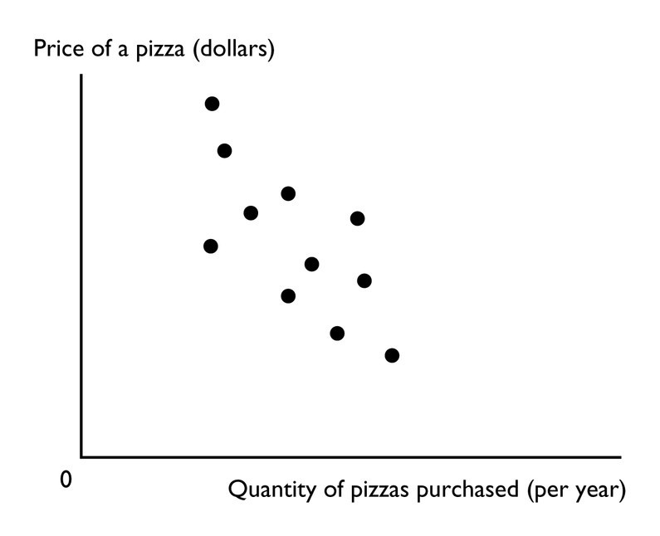
9) The figure above shows a
A) time-series graph.
B) scatter diagram.
C) cross-section graph.
D) slope.
E) trend diagram.
Answer: B
Topic: Scatter diagrams
Skill: Level 1: Definition
Section: Chapter 1 Appendix - Checkpoint 1
Status: Old
AACSB: Analytical thinking

10) A time-series graph measures
A) the value of one variable against the value of another variable.
B) the value of an economic variable for different groups in a population at a point in time.
C) time on the x-axis and the variable or variables in which we are interested on the y-axis.
D) time on the y-axis and the variable or variables in which we are interested on the x-axis.
E) time on both the x-axis and y-axis and the variable or variables in which we are interested in the rest of the figure.
Answer: C
Topic: Time-series graph
Skill: Level 1: Definition
Section: Chapter 1 Appendix - Checkpoint 1
Status: Old
AACSB: Analytical thinking
11) A time series graph
A) shows how a variable changes over time.
B) uses bars rather than lines.
C) shows points in a scatter diagram.
D) is similar to a cross-section graph because both can show trends over time.
E) is in the shape of a pie.
Answer: A
Topic: Time-series graph
Skill: Level 1: Definition
Section: Chapter 1 Appendix - Checkpoint 1
Status: Old
AACSB: Analytical thinking

12) A steep slope in a time series graph means the variable is
A) high.
B) falling.
C) rising or falling quickly.
D) rising or falling slowly.
E) very close to its trend point.
Answer: C
Topic: Time-series graph
Skill: Level 1: Definition
Section: Chapter 1 Appendix - Checkpoint 1
Status: Old
AACSB: Analytical thinking

13) Which type of economic graph reveals trends in data?
A) cross-section graph
B) time-series graph
C) scatter diagram
D) Answers A and C are correct.
E) Answers A, B, and C are all correct.
Answer: B
Topic: Time-series graph
Skill: Level 1: Definition
Section: Chapter 1 Appendix - Checkpoint 1
Status: Old
AACSB: Analytical thinking

14) A time series graph
A) shows how a certain variable changes over time.
B) uses bars rather than lines.
C) shows points that are scattered.
D) depicts a series of good economic times a nation had.
E) is not useful if the goal is to determine a variable's trend.
Answer: A
Topic: Time-series graph
Skill: Level 1: Definition
Section: Chapter 1 Appendix - Checkpoint 1
Status: Old
AACSB: Analytical thinking
15) A time-series graph displays the price of gold. The slope of the line is negative for periods when the
A) price of gold is falling.
B) price of gold is rising.
C) quantity of gold is falling.
D) price of gold is low and not changing.
E) price of gold fluctuates.
Answer: A
Topic: Time-series graph
Skill: Level 3: Using models
Section: Chapter 1 Appendix - Checkpoint 1
Status: Old
AACSB: Analytical thinking

16) A graph shows the wage rate of factory workers. The slope of the line is positive for periods when the wage rate is
A) falling.
B) rising.
C) high and not changing.
D) low and falling.
E) high and falling.
Answer: B
Topic: Time-series graph
Skill: Level 3: Using models
Section: Chapter 1 Appendix - Checkpoint 1
Status: Old
AACSB: Analytical thinking

17) A trend is
A) a measure of closeness on a scatter diagram.
B) a general tendency for a variable to rise or fall.
C) the maximum value of a variable.
D) the minimum value of a variable.
E) the difference between the maximum value of a variable and the minimum value of the variable.
Answer: B
Topic: Trend
Skill: Level 1: Definition
Section: Chapter 1 Appendix - Checkpoint 1
Status: Old
AACSB: Analytical thinking
18) A time series graph reveals whether there is a ________, which represents ________.
A) trend in a variable; a general tendency for the variable to rise or fall
B) relationship between two variables; a cross-section relationship
C) trends in two variables; unrelated variables
D) relationship between two variables; a trend in a variable
E) cross-section relationship; a general tendency for the variables to rise or fall
Answer: A
Topic: Trend
Skill: Level 1: Definition
Section: Chapter 1 Appendix - Checkpoint 1
Status: Old
AACSB: Analytical thinking

19) Trend refers to
A) the scale used on the x- and y-axes.
B) increases but not decreases of a variable.
C) decreases but not increases of a variable.
D) a general tendency for a variable to rise or fall.
E) the difference between the maximum value of the variable and the minimum value of the variable.
Answer: D
Topic: Trend
Skill: Level 1: Definition
Section: Chapter 1 Appendix - Checkpoint 1
Status: Old
AACSB: Analytical thinking
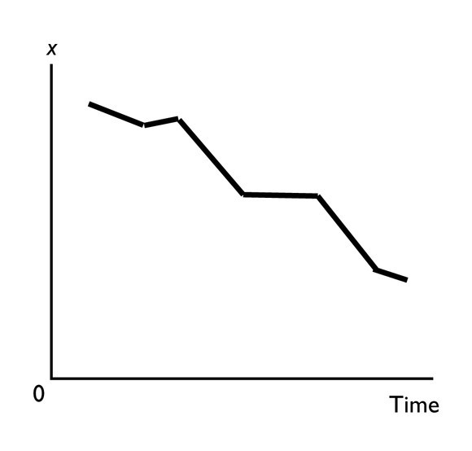
20) In the above figure, the diagram shows
A) a downward trend in x.
B) an upward trend in x.
C) a scatter diagram.
D) a two-variable scatter diagram.
E) a cross-section graph between x and time.
Answer: A
Topic: Trend
Skill: Level 1: Definition
Section: Chapter 1 Appendix - Checkpoint 1
Status: Old
AACSB: Analytical thinking

21) A cross-section graph
A) is divided into different sections.
B) shows the values of an economic variable for different groups in a population at a point in time.
C) measures time on the x-axis and the variable in which we are interested on the y-axis.
D) Both answers A and C are correct.
E) Both answers A and B are correct.
Answer: B
Topic: Cross-section graph
Skill: Level 1: Definition
Section: Chapter 1 Appendix - Checkpoint 1
Status: Old
AACSB: Analytical thinking
22) A graph that shows the value of an economic variable for different groups in a population at a given time is called a
A) scatter diagram.
B) time-series graph.
C) pie chart.
D) cross-section graph.
E) fixed-time diagram.
Answer: D
Topic: Cross-section graph
Skill: Level 1: Definition
Section: Chapter 1 Appendix - Checkpoint 1
Status: Old
AACSB: Analytical thinking

23) A graph shows the average wage of various demographic groups in 2012. The kind of graph used to show these data would be a
A) scatter diagram.
B) time-series graph.
C) cross-section graph.
D) Venn diagram.
E) fixed-year figure.
Answer: C
Topic: Cross-section graph
Skill: Level 3: Using models
Section: Chapter 1 Appendix - Checkpoint 1
Status: Old
AACSB: Analytical thinking

24) A graph showing the values of an economic variable for different groups in a population at a point in time is called a
A) cross-section graph.
B) time-series graph.
C) scatter diagram.
D) Venn diagram.
E) None of the above answers is correct.
Answer: A
Topic: Cross-section graph
Skill: Level 1: Definition
Section: Chapter 1 Appendix - Checkpoint 1
Status: Old
AACSB: Analytical thinking
25) ________ shows the values of a variable for different groups in the population at a certain point in time.
A) A time-series graph
B) The origin
C) A cross-section graph
D) A scatter plot
E) A trend-line graph
Answer: C
Topic: Cross-section graph
Skill: Level 1: Definition
Section: Chapter 1 Appendix - Checkpoint 1
Status: Old
AACSB: Analytical thinking

26) A cross-section graph
A) is divided into different sections.
B) shows values of an economic variable for different groups in a population at a point in time.
C) measures time on the x-axis and the variable in which we are interested on the y-axis.
D) Both answers A and C are correct.
E) Both answers B and C are correct.
Answer: B
Topic: Cross-section graph
Skill: Level 1: Definition
Section: Chapter 1 Appendix - Checkpoint 1
Status: Old
AACSB: Analytical thinking

27) You have data for the amount of rainfall in 50 cities for the month of June. The type of graph to best display these data would be a
A) time-series graph.
B) multi-variable time series graph.
C) cross-section graph.
D) scatter diagram.
E) trend-line diagram.
Answer: C
Topic: Cross-section graph
Skill: Level 3: Using models
Section: Chapter 1 Appendix - Checkpoint 1
Status: Old
AACSB: Analytical thinking
28) You have data for sales of pizza for each of the 50 states in 2011. The type of graph to best display these data would be a
A) cross-section graph.
B) time-series graph.
C) scatter diagram.
D) multi-variable time-series graph.
E) trend-line diagram.
Answer: A
Topic: Cross-section graph
Skill: Level 3: Using models
Section: Chapter 1 Appendix - Checkpoint 1
Status: Old
AACSB: Analytical thinking

29) A graph shows the average SAT scores for males and females in 2012. The kind of graph used to show these data would be a
A) scatter diagram.
B) time-series graph.
C) cross-section graph.
D) time-stationary graph.
E) trend figure.
Answer: C
Topic: Cross-section graph
Skill: Level 3: Using models
Section: Chapter 1 Appendix - Checkpoint 1
Status: Old
AACSB: Analytical thinking

30) Demonstrating how an economic variable changes from one year to the next is best illustrated by a
A) scatter diagram.
B) time-series graph.
C) linear graph.
D) cross-section graph.
E) Venn diagram.
Answer: B
Topic: Time-series graph
Skill: Level 1: Definition
Section: Chapter 1 Appendix - Checkpoint 1
Status: Old
AACSB: Analytical thinking
31) To show the values of an economic variable for different groups in a population at a point in time, it is best to use a
A) scatter diagram.
B) time-series graph.
C) linear graph.
D) cross-section graph
E) trend-section diagram.
Answer: D
Topic: Cross-section graph
Skill: Level 1: Definition
Section: Chapter 1 Appendix - Checkpoint 1
Status: Old
AACSB: Analytical thinking

32) A graph that shows how the amount of advertising expenditure differs among various industries can be shown
A) by a cross-section graph.
B) by a time-series graph.
C) as a trend.
D) by a scatter diagram.
E) by a trend-section graph.
Answer: A
Topic: Cross-section graph
Skill: Level 3: Using models
Section: Chapter 1 Appendix - Checkpoint 1
Status: Old
AACSB: Analytical thinking

33) A linear relationship
A) when graphed is a straight line.
B) when graphed is a line whose slope changes.
C) can be a positive or a negative relationship.
D) Both answers A and C are correct.
E) Both answers A and B are correct.
Answer: D
Topic: Linear relationship
Skill: Level 1: Definition
Section: Chapter 1 Appendix - Checkpoint 2
Status: Old
AACSB: Analytical thinking
34) A positive relationship exists between two variables if
A) one variable has "positively" no effect on the other variable.
B) a decrease in one variable is associated with an increase in the other variable.
C) a decrease in one variable is associated with a decrease in the other variable.
D) an increase in one variable is associated with both a decrease and an increase in the other variable.
E) None of the above answers is correct.
Answer: C
Topic: Positive relationship
Skill: Level 1: Definition
Section: Chapter 1 Appendix - Checkpoint 2
Status: Old
AACSB: Analytical thinking

35) If two variables are positively related, then
A) one variable causes the other.
B) an increase in one variable is accompanied by a decrease in the other.
C) an increase in one variable is accompanied by an increase in the other.
D) they change together, but not necessarily in the same direction.
E) neither variable can be positively related to any other variable.
Answer: C
Topic: Positive relationship
Skill: Level 1: Definition
Section: Chapter 1 Appendix - Checkpoint 2
Status: Old
AACSB: Analytical thinking

36) As a person increases his or her caloric intake, the person's weight increases, ceteris paribus. The relationship between the person's caloric intake and the person's weight is an example of
A) unrelated variables.
B) a positive relationship.
C) a negative relationship.
D) a single point on a graph.
E) a trended relationship.
Answer: B
Topic: Positive relationship
Skill: Level 2: Using definitions
Section: Chapter 1 Appendix - Checkpoint 2
Status: Old
AACSB: Analytical thinking

37) If there is a positive relationship between two variables,
A) the graph of the relationship will be upward sloping.
B) the graph of the relationship will be downward sloping.
C) the slope of the line graphing the relationship will be negative.
D) Both answers A and C are correct.
E) Both answers B and C are correct.
Answer: A
Topic: Positive relationship
Skill: Level 2: Using definitions
Section: Chapter 1 Appendix - Checkpoint 2
Status: Old
AACSB: Analytical thinking
38) If the change in y = 10 and the change in x = 3, there is
A) a positive relationship between y and x.
B) a negative relationship between y and x.
C) an independent relationship between y and x.
D) no relationship between y and x.
E) a +0.33 relationship between the two variables.
Answer: A
Topic: Positive relationship
Skill: Level 2: Using definitions
Section: Chapter 1 Appendix - Checkpoint 2
Status: Old
AACSB: Analytical thinking

39) Whenever people's incomes increase, they buy more guitars. Hence a scatter diagram shows that the relationship between income and guitars purchased is
A) a positive relationship.
B) a linear relationship.
C) a negative relationship.
D) some sort of relationship, but whether it is positive or negative depends on whether income is plotted on the vertical or horizontal axis.
E) a U-shaped relationship.
Answer: A
Topic: Positive relationship
Skill: Level 2: Using definitions
Section: Chapter 1 Appendix - Checkpoint 2
Status: Old
AACSB: Analytical thinking

40) Which of the following statements is correct?
A) When a line slopes downwards moving to the right, the variable measured on the x-axis and the variable measured on the y-axis are directly related.
B) When a line slopes upwards moving to the right, the variable measured on the x-axis and the variable measured on the y-axis are directly related.
C) The higher the temperature, the more ice cream people consume. Thus the temperature and ice cream consumption are inversely related.
D) If two variables are directly related, a graph of the two variables has a negative slope.
E) None of the above statements is correct.
Answer: B
Topic: Positive and negative relationships
Skill: Level 1: Definition
Section: Chapter 1 Appendix - Checkpoint 2
Status: Old
AACSB: Analytical thinking
41) If x increases whenever y decreases, then x and y are
A) not related.
B) positively related.
C) directly related.
D) negatively related.
E) related but whether positively or negatively related depends on whether the x variable or the y variable is plotted on the vertical axis.
Answer: D
Topic: Negative relationship
Skill: Level 1: Definition
Section: Chapter 1 Appendix - Checkpoint 2
Status: Old
AACSB: Analytical thinking

42) Whenever one variable increases, another variable decreases. The two variables are
A) definitely related through a third variable.
B) negatively related.
C) positively related.
D) unrelated to each other.
E) related but whether positively or negatively related depends on which variable is plotted on the vertical axis.
Answer: B
Topic: Negative relationship
Skill: Level 1: Definition
Section: Chapter 1 Appendix - Checkpoint 2
Status: Old
AACSB: Analytical thinking

43) If x increases and as a result y decreases, then x and y are
A) not related because the relationship is a causal one.
B) positively related.
C) negatively related.
D) directly related.
E) trend-line related.
Answer: C
Topic: Negative relationship
Skill: Level 1: Definition
Section: Chapter 1 Appendix - Checkpoint 2
Status: Old
AACSB: Analytical thinking
44) "As the price of gasoline increases, fewer people buy cars that are gas guzzlers." A graph showing this relationship would
A) have a negative slope.
B) have a positive relationship.
C) have a direct relationship.
D) be a horizontal line.
E) be a vertical line.
Answer: A
Topic: Negative relationship
Skill: Level 2: Using definitions
Section: Chapter 1 Appendix - Checkpoint 2
Status: Old
AACSB: Analytical thinking

45) As the number of days without rain increases, the amount of wheat grown per acre declines. A graph showing this relationship shows
A) a horizontal line.
B) a vertical line.
C) a positive relationship.
D) a line with a positive slope.
E) None of the above answers is correct.
Answer: E
Topic: Negative relationship
Skill: Level 2: Using definitions
Section: Chapter 1 Appendix - Checkpoint 2
Status: Old
AACSB: Analytical thinking

46) As the price of home heating oil rises, families buy less home heating oil. Hence a scatter diagram with the price of home heating oil on the vertical axis and the quantity purchased on the horizontal axis reveals a ________ relationship.
A) positive
B) linear
C) time-series
D) negative
E) cross-sectional
Answer: D
Topic: Negative relationship
Skill: Level 2: Using definitions
Section: Chapter 1 Appendix - Checkpoint 2
Status: Old
AACSB: Analytical thinking
47) If the change in y = -4 and the change in x = 2, there is
A) an independent relationship between y and x.
B) a positive relationship between y and x.
C) a negative relationship between y and x.
D) no relationship between y and x.
E) a relationship between x and y, but more information is needed to determine if it is a negative or positive relationship.
Answer: C
Topic: Negative relationship
Skill: Level 2: Using definitions
Section: Chapter 1 Appendix - Checkpoint 2
Status: Old
AACSB: Analytical thinking

48) An independent relationship between two variables is shown in a graph by
A) an upward-sloping line.
B) a horizontal or a vertical line.
C) a downward-sloping line.
D) a steeply sloped line.
E) any straight line curve.
Answer: B
Topic: Unrelated variables
Skill: Level 1: Definition
Section: Chapter 1 Appendix - Checkpoint 2
Status: Old
AACSB: Analytical thinking

49) If two variables are unrelated, their graph is
A) either a horizontal or a vertical line.
B) a downward-sloping line.
C) an upward-sloping line.
D) a curved line.
E) None of the above answers is correct because it is not possible to graph unrelated variables.
Answer: A
Topic: Unrelated variables
Skill: Level 1: Definition
Section: Chapter 1 Appendix - Checkpoint 2
Status: Old
AACSB: Analytical thinking
50) Consider a diagram in which the variable measured on the y-axis remains constant while the variable measured on the x-axis increases. The graph of these two variables is a
A) vertical line.
B) horizontal line.
C) line that has positive slope.
D) line that has a negative slope.
E) non-existent because the two variables are not related.
Answer: B
Topic: Unrelated variables
Skill: Level 2: Using definitions
Section: Chapter 1 Appendix - Checkpoint 2
Status: Old
AACSB: Analytical thinking

51) A graph shows the price of a pound of cucumbers on the vertical axis and the quantity of new cars sold by Honda on the horizontal axis. The price of a pound of cucumbers remains constant as the quantity of new cars sold increases. The graph of these data is a
A) horizontal line.
B) vertical line.
C) curve with a maximum.
D) positively sloped line.
E) negatively sloped line.
Answer: A
Topic: Unrelated variables
Skill: Level 2: Using definitions
Section: Chapter 1 Appendix - Checkpoint 2
Status: Old
AACSB: Analytical thinking

52) Matt pays a $50 a month membership fee at Bruno's Gym. He can exercise at the gym as many times as he wishes. If the membership fee is measured along the vertical axis and the number of times he exercises is measured along the horizontal axis, the graph between his membership fee and the number of times he exercises will
A) be a horizontal line.
B) be positively sloped.
C) be negatively sloped.
D) be a vertical line.
E) start out positively sloped and then, as Matt loses interest, become negatively sloped.
Answer: A
Topic: Unrelated variables
Skill: Level 3: Using models
Section: Chapter 1 Appendix - Checkpoint 2
Status: Old
AACSB: Analytical thinking
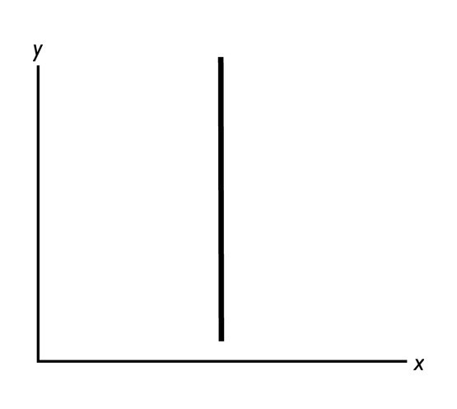
53) In the above figure, as the y variable increases,
A) the x variable is constant.
B) the x variable increases.
C) the x variable decreases.
D) the x variable at first increases but then decreases.
E) the x variable probably changes, but more information is needed to determine if it increases, decreases, or stays the same.
Answer: A
Topic: Unrelated variables
Skill: Level 1: Definition
Section: Chapter 1 Appendix - Checkpoint 2
Status: Old
AACSB: Analytical thinking
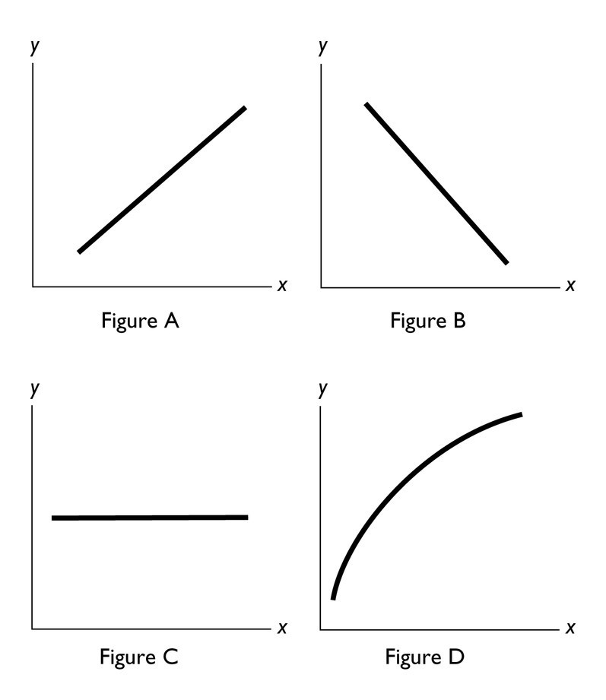

54) In the above figure, a negative relationship between x and y is shown in Figure
A) A.
B) B.
C) C.
D) D.
E) B and Figure C.
Answer: B
Topic: Negative relationship
Skill: Level 1: Definition
Section: Chapter 1 Appendix - Checkpoint 2
Status: Old
AACSB: Analytical thinking

55) In the above figure, no relationship between x and y is shown in Figure
A) A.
B) B.
C) C.
D) D.
E) A and Figure B.
Answer: C
Topic: Unrelated variables
Skill: Level 1: Definition
Section: Chapter 1 Appendix - Checkpoint 2
Status: Old
AACSB: Analytical thinking
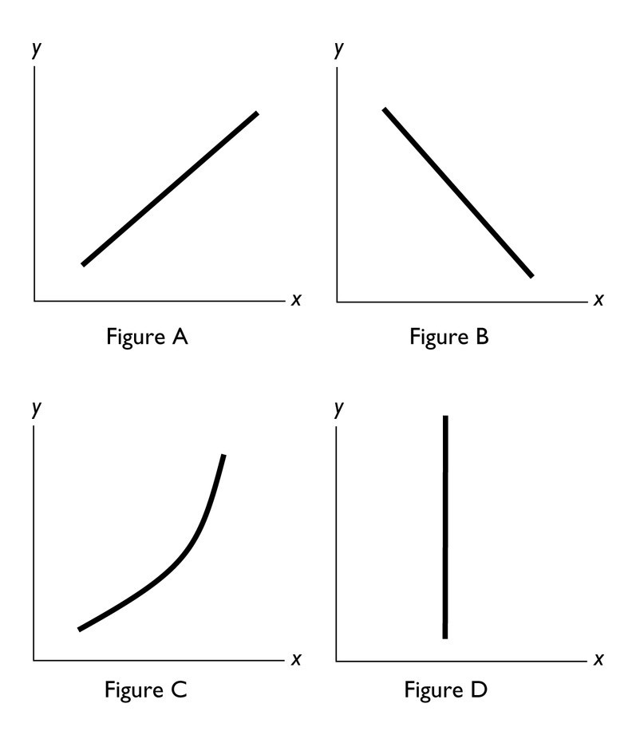
56) In the diagram above, which figure(s) show(s) a direct relationship between the variables?
A) both B and C
B) both A and C
C) only A
D) only D
E) only B
Answer: B
Topic: Positive relationship
Skill: Level 2: Using definitions
Section: Chapter 1 Appendix - Checkpoint 2
Status: Old
AACSB: Analytical thinking

57) In the diagram above, which figure(s) show(s) an inverse relationship between the variables?
A) both B and C
B) only B
C) both A and C
D) only D
E) only C
Answer: B
Topic: Negative relationship
Skill: Level 2: Using definitions
Section: Chapter 1 Appendix - Checkpoint 2
Status: Old
AACSB: Analytical thinking
58) In the diagram above, which figure(s) show(s) no relationship between the variables?
A) both B and C
B) only B
C) both A and C
D) only D
E) both A and B
Answer: D
Topic: Unrelated variables
Skill: Level 2: Using definitions
Section: Chapter 1 Appendix - Checkpoint 2
Status: Old
AACSB: Analytical thinking

59) If a curve rises and then falls, it has a
A) maximum.
B) minimum.
C) linear relationship.
D) constant slope relationship.
E) slope that is negative and then positive.
Answer: A
Topic: Maximum
Skill: Level 1: Definition
Section: Chapter 1 Appendix - Checkpoint 2
Status: Old
AACSB: Analytical thinking

60) As a shoe factory adds more workers, shoe production grows, reaches a maximum, and then shrinks. In a diagram that has the number of workers on the horizontal axis and the number of shoes on the vertical axis, the relationship between the number of workers and the number of shoes starts as ________ and then, after the maximum point, is ________.
A) positive; negative
B) negative; positive
C) linear; negative
D) positive; linear
E) positive; nonexistent
Answer: A
Topic: Maximum
Skill: Level 3: Using models
Section: Chapter 1 Appendix - Checkpoint 2
Status: Old
AACSB: Analytical thinking
61) As a curve approaches a maximum point, the slope will
A) be positive and then negative after the maximum point.
B) be negative and then positive after the maximum point.
C) remain constant on either side of the maximum point.
D) increase before and after the maximum point.
E) decrease before and after the maximum point.
Answer: A
Topic: Maximum
Skill: Level 2: Using definitions
Section: Chapter 1 Appendix - Checkpoint 2
Status: Old
AACSB: Analytical thinking

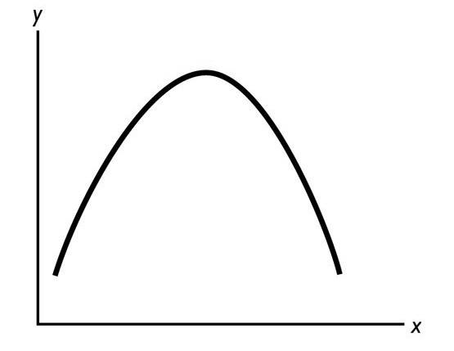
62) In the figure above, the relationship between the x variable and the y variable
A) is positive.
B) is negative.
C) starts by being positive and then becomes negative.
D) starts by being negative and then becomes positive.
E) is non-existent because the two variables are unrelated.
Answer: C
Topic: Maximum
Skill: Level 2: Using definitions
Section: Chapter 1 Appendix - Checkpoint 2
Status: Old
AACSB: Analytical thinking

63) If a curve falls and then rises, it
A) has a maximum.
B) has a minimum.
C) has a linear relationship.
D) has a constant slope relationship.
E) shows no relationship between the two variables.
Answer: B
Topic: Minimum
Skill: Level 1: Definition
Section: Chapter 1 Appendix - Checkpoint 2
Status: Old
AACSB: Analytical thinking
64) Moving from left to right, a U-shaped curve starts with a
A) positive slope, reaches a maximum, then ends with a negative slope.
B) positive slope, reaches a minimum, then ends with a negative slope.
C) negative slope, reaches a maximum, then ends with a positive slope.
D) negative slope, reaches a minimum, then ends with a positive slope.
E) negative slope, reaches a minimum, then ends with a negative slope.
Answer: D
Topic: Minimum
Skill: Level 2: Using definitions
Section: Chapter 1 Appendix - Checkpoint 2
Status: Old
AACSB: Analytical thinking

65) The minimum point of a U-shaped curve,
A) is a point where the variable is neither increasing nor decreasing.
B) has a slope equal to zero.
C) has the maximum slope possible.
D) Both answers A and B are correct.
E) Both answers A and C are correct.
Answer: D
Topic: Minimum
Skill: Level 1: Definition
Section: Chapter 1 Appendix - Checkpoint 2
Status: Old
AACSB: Analytical thinking

66) An economist observed that as more computers are added to a factory, the costs of production initially decline, reach a minimum, and then rise. In a diagram that has costs on the vertical axis and the number of computers on the horizontal axis, the relationship always is
A) negative and then linear after the minimum point.
B) positive and then negative after the minimum point.
C) negative and then positive after the minimum point.
D) linear and then positive after the minimum point.
E) negative both before and after the minimum point.
Answer: C
Topic: Minimum
Skill: Level 3: Using models
Section: Chapter 1 Appendix - Checkpoint 2
Status: Old
AACSB: Analytical thinking
67) If whenever one variable increases, another variable also increases, then these two variables are ________ related.
A) positively
B) negatively
C) inversely
D) cross-sectionally
E) trend-line
Answer: A
Topic: Positive relationship
Skill: Level 1: Definition
Section: Chapter 1 Appendix - Checkpoint 2
Status: Old
AACSB: Analytical thinking

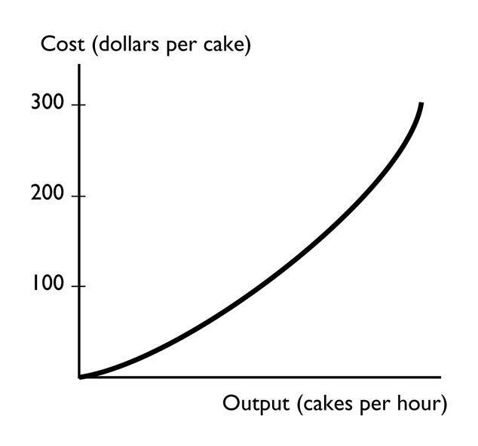
68) The graph shows a
A) positive relationship that becomes steeper.
B) negative relationship that becomes steeper.
C) positive relationship that becomes less steep.
D) negative relationship that become less steep.
E) negative trend between the total cost of a cake and the output of cakes.
Answer: A
Topic: Positive relationship
Skill: Level 3: Using models
Section: Chapter 1 Appendix - Checkpoint 2
Status: Old
AACSB: Analytical thinking
69) A graph of the relationship between two variables is a line that slopes down to the right. These two variables are ________ related.
A) positively
B) directly
C) negatively
D) not
E) trend-line
Answer: C
Topic: Negative relationship
Skill: Level 1: Definition
Section: Chapter 1 Appendix - Checkpoint 2
Status: Old
AACSB: Analytical thinking

70) A graph shows that the number of U.S. tourists visiting a Caribbean island increases as the temperature in the northeastern United States falls. The graph shows
A) a positive relationship.
B) a direct relationship.
C) a negative relationship.
D) no relationship.
E) an invalid relationship.
Answer: C
Topic: Negative relationship
Skill: Level 1: Definition
Section: Chapter 1 Appendix - Checkpoint 2
Status: Old
AACSB: Analytical thinking
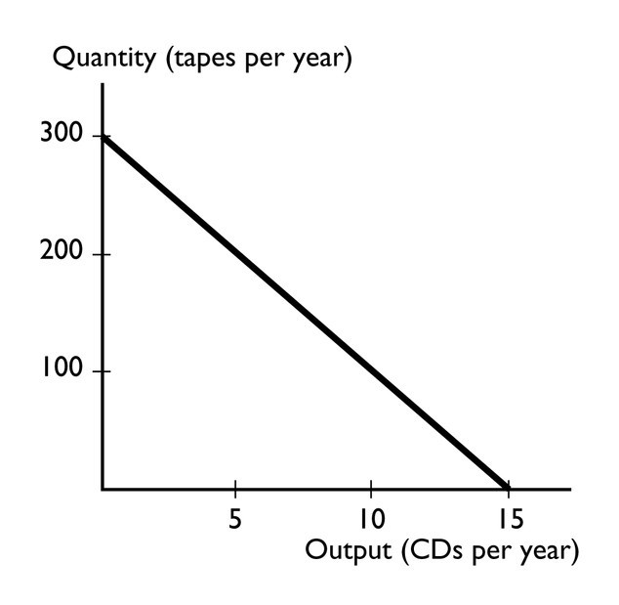
71) The graph shows a
A) positive relationship that becomes less steep.
B) negative relationship that is linear.
C) positive relationship that is linear.
D) negative relationship that become less steep.
E) None of the above answers is correct.
Answer: B
Topic: Negative relationship
Skill: Level 3: Using models
Section: Chapter 1 Appendix - Checkpoint 2
Status: Old
AACSB: Analytical thinking
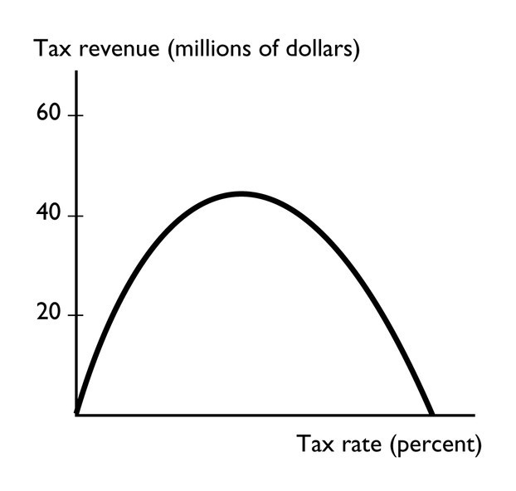
72) The graph shows
A) a relationship with a minimum.
B) a relationship with a maximum.
C) no relationship.
D) a linear relationship.
E) a cross-section relationship.
Answer: B
Topic: Maximum
Skill: Level 3: Using models
Section: Chapter 1 Appendix - Checkpoint 2
Status: Old
AACSB: Analytical thinking
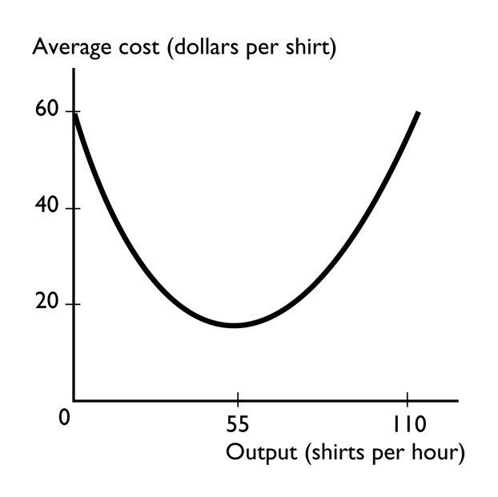
73) The graph shows
A) a relationship with a minimum.
B) a relationship with a maximum.
C) no relationship.
D) a relationship that becomes less steep.
E) a cross-section relationship.
Answer: A
Topic: Minimum
Skill: Level 3: Using models
Section: Chapter 1 Appendix - Checkpoint 2
Status: Old
AACSB: Analytical thinking

74) Two variables are unrelated if their graph is
i. a vertical line.
ii. a 45 degree line.
iii. a horizontal line.
A) i only
B) ii only
C) iii only
D) i and iii
E) i, ii, and iii
Answer: D
Topic: Unrelated variables
Skill: Level 1: Definition
Section: Chapter 1 Appendix - Checkpoint 2
Status: Old
AACSB: Analytical thinking
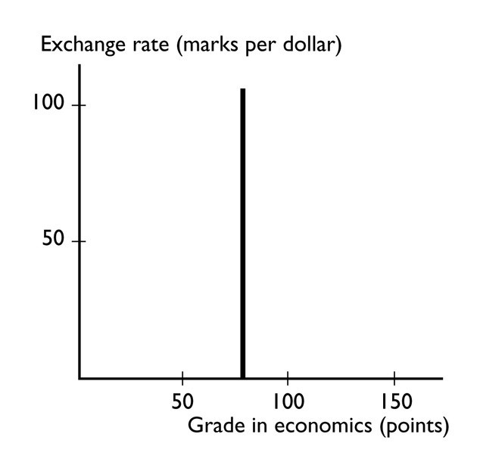
75) The graph shows
A) a positive relationship that becomes less steep.
B) a negative relationship that is linear.
C) a positive relationship that is linear.
D) no relationship between the variables.
E) a trend relationship between the variables.
Answer: D
Topic: Unrelated variables
Skill: Level 3: Using models
Section: Chapter 1 Appendix - Checkpoint 2
Status: Old
AACSB: Analytical thinking

76) A slope is measured as the
A) value of the variable measured on the y-axis divided by the value of the variable measured on the x-axis.
B) value of the variable measured on the x-axis divided by the value of the variable measured on the y-axis.
C) change in the value of variable on the y-axis divided by the change in the value of the variable on the x-axis.
D) value of the variable measured on the y-axis minus the value of the variable measured on the x-axis.
E) change in the value of variable on the x-axis divided by the change in the value of the variable on the y-axis.
Answer: C
Topic: Slope
Skill: Level 1: Definition
Section: Chapter 1 Appendix - Checkpoint 3
Status: Old
AACSB: Analytical thinking
77) A slope is measured as the
A) value of the variable measured on the y-axis divided by the value of the variable measured on the x-axis.
B) value of the variable measured on the x-axis divided by the value of the variable measured on the y-axis.
C) change in the value of variable on the y-axis divided by the change in the value of the variable on the x-axis.
D) value of the variable measured on the y-axis minus the value of the variable measured on the x-axis.
E) value of the variable measured on the x-axis minus the value of the variable measured on the y-axis.
Answer: C
Topic: Slope
Skill: Level 1: Definition
Section: Chapter 1 Appendix - Checkpoint 3
Status: Old
AACSB: Analytical thinking

78) "The change in the value of the variable measured on the y-axis divided by the change in the value of the variable measured on the x-axis" is the definition of
A) a graph.
B) slope.
C) a curve.
D) a relationship.
E) a trend.
Answer: B
Topic: Slope
Skill: Level 1: Definition
Section: Chapter 1 Appendix - Checkpoint 3
Status: Old
AACSB: Analytical thinking

79) The slope of a line equals the change in the variable measured along the
A) x-axis divided by the change in the variable measured along the y-axis.
B) y-axis divided by the change in the variable measured along the x-axis.
C) x-axis minus the change in the variable measured along the y-axis.
D) x-axis multiplied by the change in the variable measured along the y-axis.
E) y-axis minus the change in the variable measured along the x-axis.
Answer: B
Topic: Slope
Skill: Level 1: Definition
Section: Chapter 1 Appendix - Checkpoint 3
Status: Old
AACSB: Analytical thinking
80) The slope
A) of a straight line is the same regardless of where on the line it is calculated.
B) equals the change in the value of the variable measured on the x-axis divided by the change in the variable measured on the y-axis.
C) will be small if a large change in the variable measured on the y-axis is associated with a small change in the variable measured on the x-axis.
D) equals the change in the value of the variable measured on the y-axis minus the change in the variable measured on the x-axis.
E) falls as the x variable increases if the line has a negative slope.
Answer: A
Topic: Slope
Skill: Level 1: Definition
Section: Chapter 1 Appendix - Checkpoint 3
Status: Old
AACSB: Analytical thinking

81) With y measured on the vertical axis and x measured on the horizontal axis, the slope of a straight line is defined as
A) y/x.
B) x/y.
C) (change in y)/(change in x).
D) (change in x)/(change in y).
E) y - x.
Answer: C
Topic: Slope of a straight line
Skill: Level 2: Using definitions
Section: Chapter 1 Appendix - Checkpoint 3
Status: Old
AACSB: Analytical thinking

82) In a graph, a straight line has a negative slope if the line
A) is vertical.
B) is horizontal.
C) falls from left to right.
D) rises from left to right.
E) shows a trend.
Answer: C
Topic: Slope
Skill: Level 2: Using definitions
Section: Chapter 1 Appendix - Checkpoint 3
Status: Old
AACSB: Analytical thinking
83) A curve with a positive but decreasing slope represents a relationship where, every time the variable measured along the horizontal axis increases by one unit, the variable measured along the vertical axis
A) increases by a constant amount.
B) increases by an increasing amount.
C) increases by a decreasing amount.
D) decreases.
E) does not change by much.
Answer: C
Topic: Slope
Skill: Level 2: Using definitions
Section: Chapter 1 Appendix - Checkpoint 3
Status: Old
AACSB: Analytical thinking

84) The slope
A) of a straight line is the same regardless of where on the line it is calculated.
B) equals the change in the value of the variable measured on the vertical axis divided by the change in the variable measured along the horizontal axis.
C) will be small if a large change in the variable measured on the vertical axis is associated with a small change in the variable measured along the horizontal axis.
D) Answers A and B are correct.
E) Answers A and C are correct.
Answer: D
Topic: Slope
Skill: Level 2: Using definitions
Section: Chapter 1 Appendix - Checkpoint 3
Status: Old
AACSB: Analytical thinking

85) Which of the following statements is correct?
A) The slope of a straight line changes depending where on the line it is calculated.
B) The slope of a curved line is not defined because it is impossible to calculate the slope along a curved line.
C) A straight line that slopes upward moving to the right has a positive slope.
D) Answers A and B are correct.
E) Answers A and C are correct.
Answer: C
Topic: Slope
Skill: Level 2: Using definitions
Section: Chapter 1 Appendix - Checkpoint 3
Status: Old
AACSB: Analytical thinking
86) If a small change in the x variable results in a large change in the y variable, the curve will be
A) positively sloped.
B) negatively sloped.
C) steep.
D) flat.
E) trended.
Answer: C
Topic: Slope
Skill: Level 2: Using definitions
Section: Chapter 1 Appendix - Checkpoint 3
Status: Old
AACSB: Analytical thinking

87) Suppose the relationship between a person's age and his or her height is plotted with the age measured along the x-axis and the height measured along the y-axis. Then, the curve showing this relationship is
A) a straight line with a positive slope.
B) positively sloped and becoming less steep.
C) a straight line with a negative slope.
D) negatively sloped and becoming less steep.
E) positively sloped and becoming more steep.
Answer: B
Topic: Positive slope
Skill: Level 3: Using models
Section: Chapter 1 Appendix - Checkpoint 3
Status: Old
AACSB: Analytical thinking

88) If the quantity of the variable on the y-axis increases by 10 when the quantity of the variable on the x-axis decreases by 2, then the slope of the curve equals
A) 2.
B) -10.
C) 10.
D) -5.
E) None of the above answers is correct.
Answer: D
Topic: Slope
Skill: Level 2: Using definitions
Section: Chapter 1 Appendix - Checkpoint 3
Status: Old
AACSB: Analytical thinking
89) If the quantity of the variable on the y-axis increases by 3 when the quantity of the variable on the x-axis increases by 4, then the slope of the curve equals
A) 3.
B) 4.
C) 3/4.
D) 4/3.
E) 1.
Answer: C
Topic: Slope
Skill: Level 2: Using definitions
Section: Chapter 1 Appendix - Checkpoint 3
Status: Old
AACSB: Analytical thinking

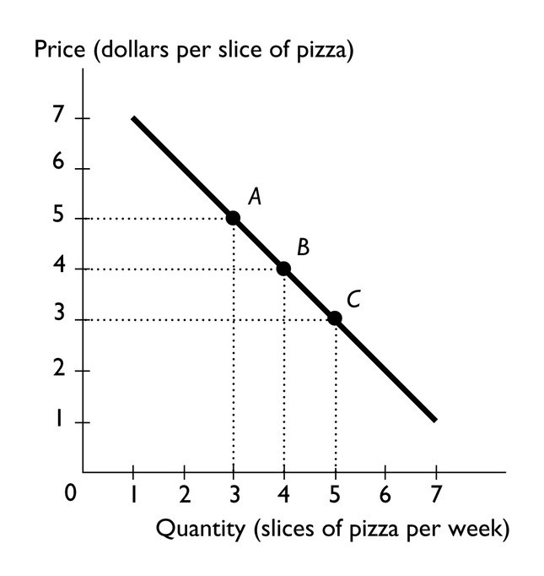
90) The above figure shows the relationship between the price of a slice of pizza and how many slices of pizza Ricardo buys in a week. Between points A and B, the slope of the line equals
A) -5.
B) -4.
C) -3.
D) -1.
E) -2
Answer: D
Topic: Slope
Skill: Level 2: Using definitions
Section: Chapter 1 Appendix - Checkpoint 3
Status: Old
AACSB: Analytical thinking
91) The above figure shows the relationship between the price of a slice of pizza and how many slices of pizza Ricardo buys in a week. Between points A and B, the slope of the line is ________ the slope of the line between points B and C.
A) greater than
B) equal to
C) less than
D) unrelated to
E) not comparable to
Answer: B
Topic: Slope
Skill: Level 2: Using definitions
Section: Chapter 1 Appendix - Checkpoint 3
Status: Old
AACSB: Analytical thinking

92) Moving rightward along a straight line, the slope of the line
A) always increases.
B) always decreases.
C) stays the same.
D) increases if the line slopes upward to the right.
E) decreases if the line slopes downward to the right.
Answer: C
Topic: Slope of a straight line
Skill: Level 1: Definition
Section: Chapter 1 Appendix - Checkpoint 3
Status: Old
AACSB: Analytical thinking

93) A straight line falls when moving rightward along it. Hence the slope of the line is
A) positive.
B) negative.
C) undefined.
D) zero because it is a straight line.
E) perhaps positive, negative, or zero, but without more information it is impossible to determine.
Answer: B
Topic: Slope of a straight line
Skill: Level 1: Definition
Section: Chapter 1 Appendix - Checkpoint 3
Status: Old
AACSB: Analytical thinking
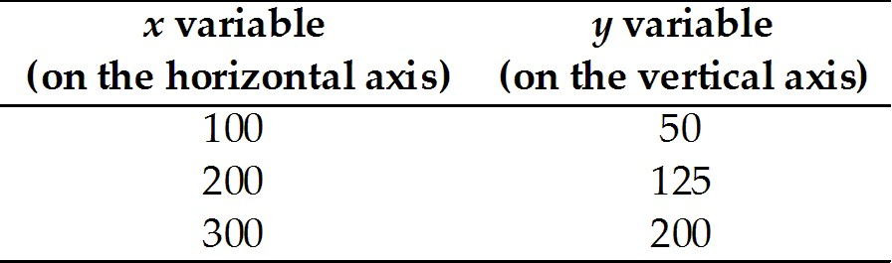

94) The table above shows data on two variables. If these data were graphed, the slope of the line would be
A) 1/2.
B) 4/3.
C) 2/3.
D) 3/4.
E) 2.
Answer: D
Topic: Slope of a straight line
Skill: Level 2: Using definitions
Section: Chapter 1 Appendix - Checkpoint 3
Status: Old
AACSB: Analytical thinking

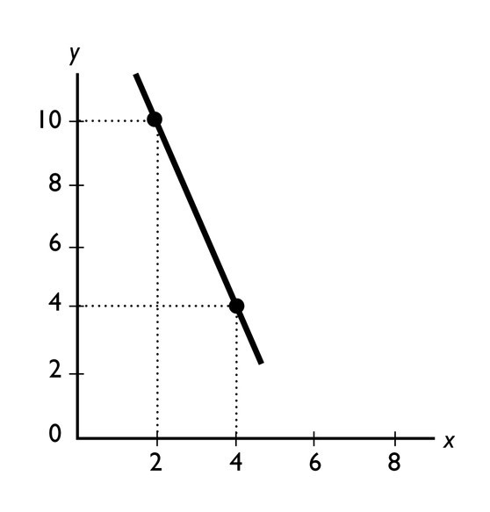
95) The slope of the line shown in the above figure is
A) -1/3.
B) -5.
C) -1.
D) -3.
E) -10.
Answer: D
Topic: Slope of a straight line
Skill: Level 2: Using definitions
Section: Chapter 1 Appendix - Checkpoint 3
Status: Old
AACSB: Analytical thinking
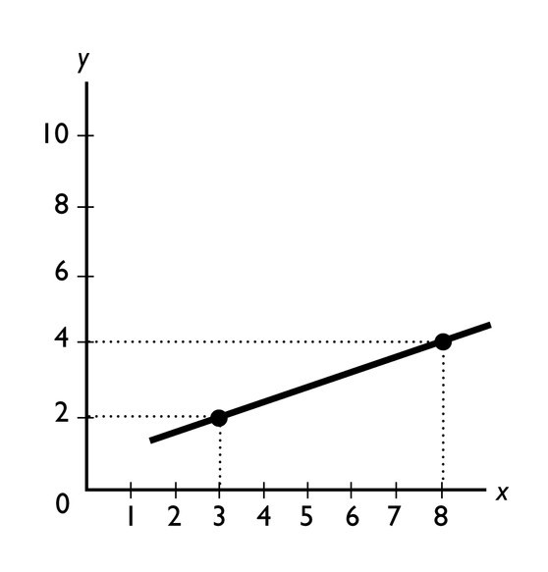
96) The slope of the line shown in the above figure is
A) 5.
B) 2/5.
C) 2/3.
D) 5/2.
E) 2.
Answer: B
Topic: Slope of a straight line
Skill: Level 2: Using definitions
Section: Chapter 1 Appendix - Checkpoint 3
Status: Old
AACSB: Analytical thinking
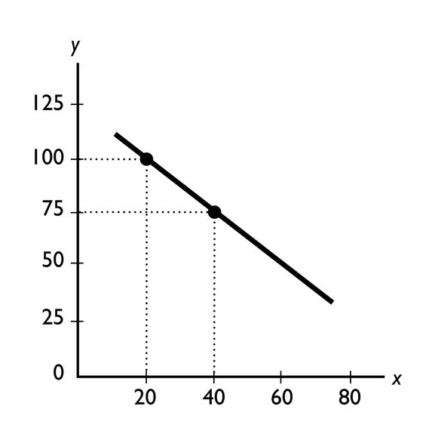
97) The slope of the line shown in the above figure is
A) -1 1/3.
B) -1 2/3.
C) -1.25.
D) -0.80.
E) 5.
Answer: C
Topic: Slope of a straight line
Skill: Level 2: Using definitions
Section: Chapter 1 Appendix - Checkpoint 3
Status: Old
AACSB: Analytical thinking
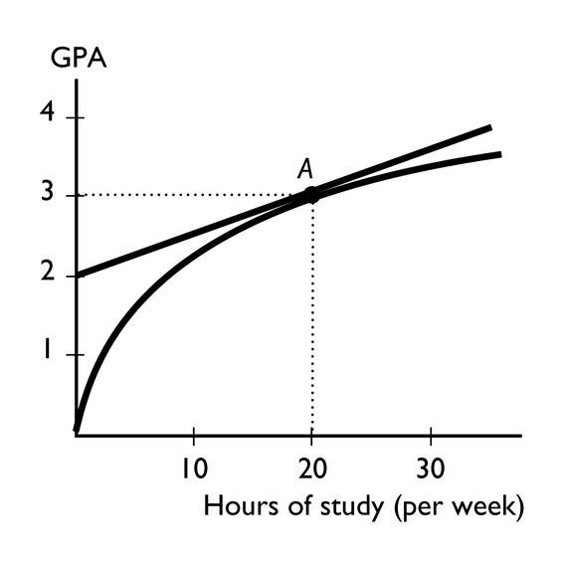
98) The figure above shows the relationship between the time a student spends studying and the student's GPA that semester. The slope of the relationship at point A equals
A) 3.
B) 3/20
C) 2/20.
D) 1/20.
E) 0.
Answer: D
Topic: Slope
Skill: Level 2: Using definitions
Section: Chapter 1 Appendix - Checkpoint 3
Status: Old
AACSB: Analytical thinking
99) In the above figure, which of the figures shows a relationship between x and y with a negative slope?
A) Figure A
B) Figure B
C) Figure C
D) Figure D
E) Both Figure A and Figure B
Answer: B
Topic: Negative slope
Skill: Level 1: Definition
Section: Chapter 1 Appendix - Checkpoint 3
Status: Old
AACSB: Analytical thinking
100) In the above figure, which of the figures show(s) a relationships between x and y with a positive slope?
A) Figure A and Figure D
B) Figure B and Figure C
C) Figure C only
D) Figure D only
E) Figure A and Figure B
Answer: A
Topic: Positive slope
Skill: Level 2: Using definitions
Section: Chapter 1 Appendix - Checkpoint 3
Status: Old
AACSB: Analytical thinking

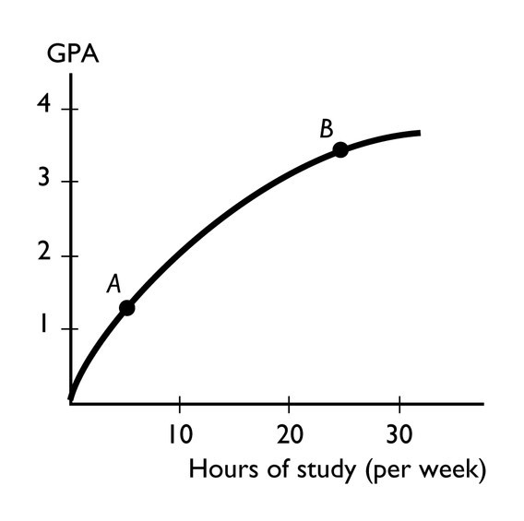
101) The figure above shows the relationship between the time a student spends studying and the student's GPA that semester. This figure shows ________ relationship between the time spent studying and the GPA.
A) a positive but not linear
B) a negative
C) no
D) a positive, linear
E) cross-sectionally trended
Answer: A
Topic: Positive relationship
Skill: Level 2: Using definitions
Section: Chapter 1 Appendix - Checkpoint 3
Status: Old
AACSB: Analytical thinking
102) The figure above shows the relationship between the time a student spends studying and the student's GPA that semester. The slope of the relationship at point A ________ the slope at point B.
A) is greater than
B) is less than
C) is equal to
D) cannot be compared to
E) can be compared but more information is needed to determine whether the slope is greater than, less than, or equal to
Answer: A
Topic: Slope
Skill: Level 3: Using models
Section: Chapter 1 Appendix - Checkpoint 3
Status: Old
AACSB: Analytical thinking
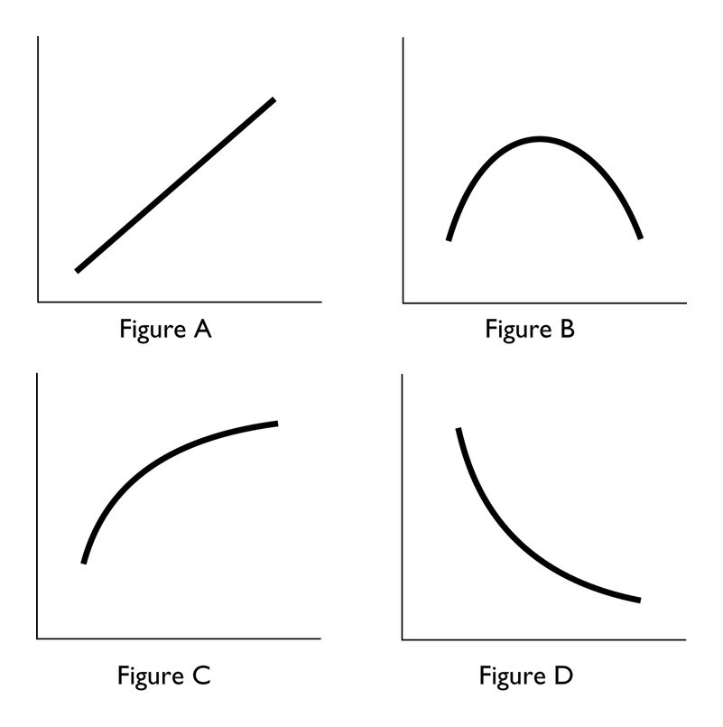
103) In the above, which figure(s) show(s) relationship between the variables that is always positive?
A) Figure A only
B) Figures C and D
C) Figures A and C
D) Figures A, C, and D
E) Figures A and B
Answer: C
Topic: Positive relationship
Skill: Level 3: Using models
Section: Chapter 1 Appendix - Checkpoint 3
Status: Old
AACSB: Analytical thinking

104) In the above, which figure(s) show(s) a relationship between the variables that is always negative?
A) Figure A only
B) Figure D only
C) Figures A and C
D) Figures A, C, and D
E) Figure B only
Answer: B
Topic: Negative relationship
Skill: Level 3: Using models
Section: Chapter 1 Appendix - Checkpoint 3
Status: Old
AACSB: Analytical thinking
105) In the above, which figure(s) show(s) both a positive and a negative relationship between the variables?
A) Figure A
B) Figure B
C) Figure C
D) Figure D
E) Figure A, B, and D
Answer: B
Topic: Positive and negative relationships
Skill: Level 3: Using models
Section: Chapter 1 Appendix - Checkpoint 3
Status: Old
AACSB: Analytical thinking

106) In the above, which figure(s) has (have) at least one point at which the slope equals zero?
A) Figure B only
B) Figures A and C
C) Figure D only
D) Figures A, C, and D
E) Figures A and D
Answer: A
Topic: Slope
Skill: Level 3: Using models
Section: Chapter 1 Appendix - Checkpoint 3
Status: Old
AACSB: Analytical thinking

107) In the above, in which figure(s) is (are) the slope the same at every point?
A) Figure A only
B) Figures A and C
C) Figure B only
D) Figures A, C, and D
E) Figures C and D
Answer: A
Topic: Slope
Skill: Level 3: Using models
Section: Chapter 1 Appendix - Checkpoint 3
Status: Old
AACSB: Analytical thinking
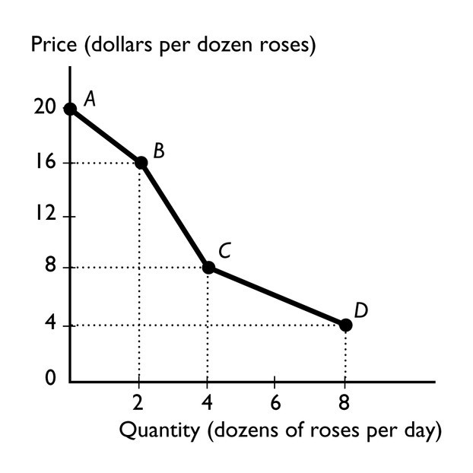
108) The figure above shows the relationship between the price of a dozen roses and the quantity of roses a florist can sell. The relationship between the price and the quantity the florist can sell is
A) positive.
B) negative.
C) nonexistent.
D) linear.
E) cross-sectionally trended.
Answer: B
Topic: Negative relationship
Skill: Level 2: Using definitions
Section: Chapter 1 Appendix - Checkpoint 3
Status: Old
AACSB: Analytical thinking

109) The figure above shows the relationship between the price of a dozen roses and the quantity of roses a florist can sell. The slope between points A and B is
A) 20.
B) 16.
C) 2.
D) 4
E) nonexistent because at point A, no roses are sold.
Answer: C
Topic: Slope
Skill: Level 3: Using models
Section: Chapter 1 Appendix - Checkpoint 3
Status: Old
AACSB: Analytical thinking
110) The figure above shows the relationship between the price of a dozen roses and the quantity of roses a florist can sell. The slope between points B and C equals
A) 16.
B) 8.
C) 4.
D) 2.
E) 14.
Answer: C
Topic: Slope
Skill: Level 3: Using models
Section: Chapter 1 Appendix - Checkpoint 3
Status: Old
AACSB: Analytical thinking

111) The figure above shows the relationship between the price of a dozen roses and the quantity of roses a florist can sell. The slope between points C and D equals
A) 8.
B) 4.
C) 2.
D) 1.
E) 12
Answer: D
Topic: Slope
Skill: Level 3: Using models
Section: Chapter 1 Appendix - Checkpoint 3
Status: Old
AACSB: Analytical thinking
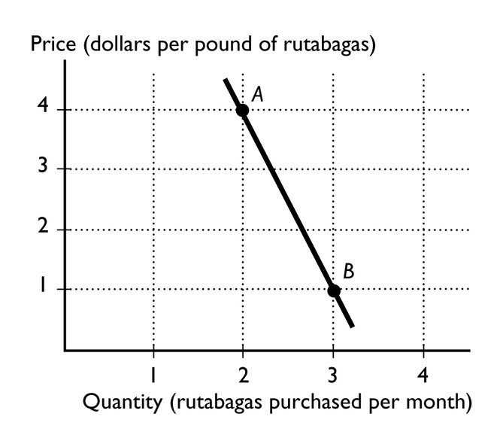
112) In the figure above, between points A and B, what is the slope of the line?
A) 4
B) 1
C) 3
D) -3
E) 0
Answer: D
Topic: Slope
Skill: Level 3: Using models
Section: Chapter 1 Appendix - Checkpoint 3
Status: Old
AACSB: Analytical thinking
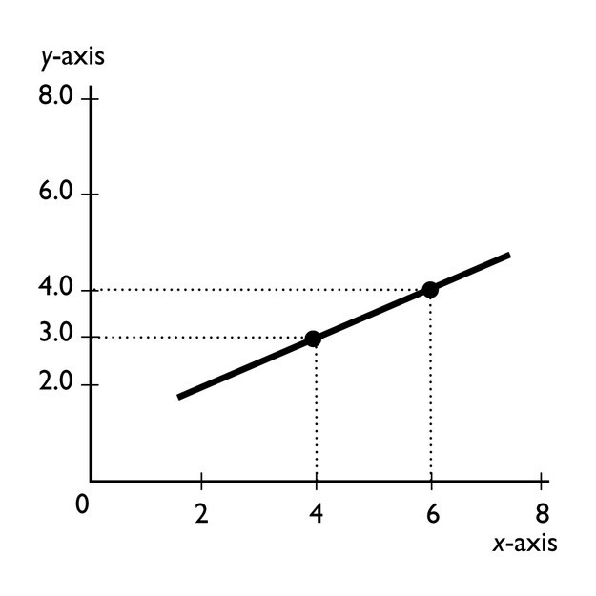
113) What is the slope of the line in the graph?
A) +1/2
B) -1/2
C) + 2
D) -2
E) -3/4
Answer: A
Topic: Slope of a straight line
Skill: Level 2: Using definitions
Section: Chapter 1 Appendix - Checkpoint 3
Status: Old
AACSB: Analytical thinking
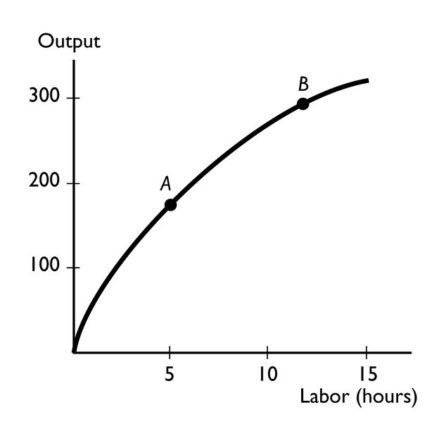
114) The slope of the curve at point B
A) is greater than the slope at point A.
B) is less than the slope at point A.
C) is equal to the slope at point A.
D) cannot be compared with the slope at point A.
E) can be compared with the slope at point A, but more information is needed to determine if the slope is greater than, less than, or equal to the slope at point A.
Answer: B
Topic: Slope
Skill: Level 3: Using models
Section: Chapter 1 Appendix - Checkpoint 3
Status: Old
AACSB: Analytical thinking

115) The Latin term "ceteris paribus" means
A) "false unless proven true."
B) "other things remaining the same."
C) "after this, therefore because of this."
D) "what is true of the whole is not necessarily true of the parts."
E) "obviously true."
Answer: B
Topic: Ceteris paribus
Skill: Level 1: Definition
Section: Chapter 1 Appendix - Checkpoint 4
Status: Old
AACSB: Reflective thinking
116) Which of the following statements is the best example of the term ceteris paribus?
A) An economist holds other factors constant when he examines the relationship between tax rates and tax revenues.
B) More money should be spent on cleaning up the environment.
C) The government budget surplus was $200 billion in 2000 because the economy was growing.
D) An increase in the budget surplus after an increase in tax rates implies that tax rate increases cause budget surpluses.
E) When studying the effects of a budget deficit, an economist must take account of all the factors involved.
Answer: A
Topic: Ceteris paribus
Skill: Level 3: Using models
Section: Chapter 1 Appendix - Checkpoint 4
Status: Old
AACSB: Reflective thinking

117) To graph a relationship involving more than two variables, we use which assumption?
A) linear assumption
B) positive relationship assumption
C) marginal analysis
D) ceteris paribus
E) trend assumption
Answer: D
Topic: Ceteris paribus
Skill: Level 1: Definition
Section: Chapter 1 Appendix - Checkpoint 4
Status: Old
AACSB: Analytical thinking

118) To graph a relationship among several variables, we hold all but ________ variable(s) constant and use the ________ assumption.
A) one; scarcity
B) two; ceteris paribus
C) three; scarcity
D) one; ceteris paribus
E) one; absence of trend
Answer: B
Topic: Relationships among more than two variables
Skill: Level 1: Definition
Section: Chapter 1 Appendix - Checkpoint 4
Status: Old
AACSB: Analytical thinking
119) We are investigating the relationship among three variables. We have graphed two of them. Suppose that the variable that is not measured on the x-axis or the y-axis changes. Then, there is
A) a movement along the plotted curve.
B) a shift in the plotted curve.
C) no impact on the plotted curve because the variable is not measured on either of the axes.
D) an omitted variable.
E) a violation of the absence of trend assumption.
Answer: B
Topic: Relationships among more than two variables
Skill: Level 1: Definition
Section: Chapter 1 Appendix - Checkpoint 4
Status: Old
AACSB: Analytical thinking

120) When analyzing graphically the relationship between more than two variables, which of the following must be used?
A) positive slope assumption
B) assumption of little change
C) ceteris paribus
D) negative slope assumption
E) the assumption that only relevant factors change
Answer: C
Topic: Ceteris paribus
Skill: Level 2: Using definitions
Section: Chapter 1 Appendix - Checkpoint 4
Status: Old
AACSB: Analytical thinking

121) Ceteris paribus when graphing a relationship refers to
A) letting all the variables change at once.
B) changing the origin of the graph.
C) holding constant all but two variables.
D) rescaling the coordinates.
E) swapping the axes so that the x-axis is the vertical axis and the y-axis is the horizontal axis.
Answer: C
Topic: Ceteris paribus
Skill: Level 2: Using definitions
Section: Chapter 1 Appendix - Checkpoint 4
Status: Old
AACSB: Analytical thinking
122) When two variables in a graph are related to a third, changing the third causes
A) a movement along the curve.
B) a shift of the curve.
C) no change in the curve because the third variable isn't on the axes.
D) either a shift or a movement in the curve but more information is needed to determine which occurs.
E) None of the above answers is correct.
Answer: B
Topic: Relationships among more than two variables
Skill: Level 2: Using definitions
Section: Chapter 1 Appendix - Checkpoint 4
Status: Old
AACSB: Analytical thinking

123) On a graph showing the relationship between x and y, the ceteris paribus condition implies that
A) no other variables are related to x and y.
B) the value of x is held constant.
C) the value of y is held constant.
D) other variables not shown are held constant.
E) the value of x and the value of y are held constant.
Answer: D
Topic: Ceteris paribus
Skill: Level 2: Using definitions
Section: Chapter 1 Appendix - Checkpoint 4
Status: Old
AACSB: Analytical thinking

124) Three variables are related and two of them are plotted in a figure. If the variable that is not measured on either the x-axis or the y-axis changes, then there is
A) a movement along the drawn curve.
B) a shift in the curve.
C) no impact on the curve because the variable is not measured on either of the axes.
D) either a shift in the curve or a movement along the curve, but more information is needed to determine which.
E) None of the above answers is correct.
Answer: B
Topic: Changes in third variable
Skill: Level 1: Definition
Section: Chapter 1 Appendix - Checkpoint 4
Status: Old
AACSB: Analytical thinking
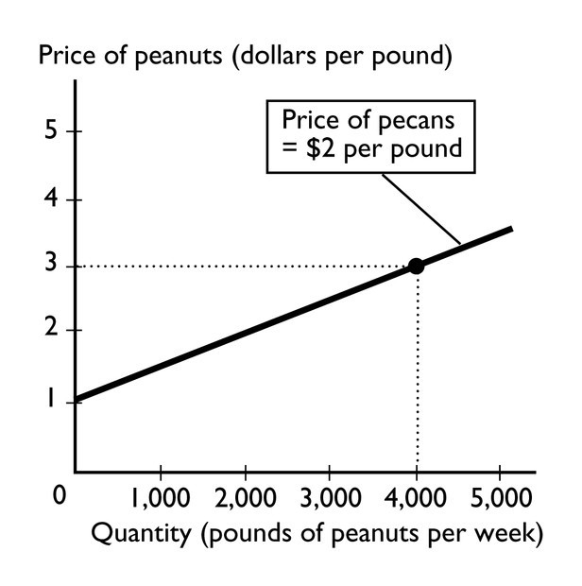
125) The above figure shows how many pounds of peanuts farmers are willing to sell at different prices per pound of peanuts. If the price of a pound of peanuts is $1 and the price of a pound of pecans is $2, peanut farmers are willing to sell
A) no peanuts.
B) 1,000 pounds of peanuts.
C) 2,000 pounds of peanuts.
D) 4,000 pounds of peanuts.
E) more than 4,000 pounds of peanuts.
Answer: A
Topic: Relationships among more than two variables
Skill: Level 3: Using models
Section: Chapter 1 Appendix - Checkpoint 4
Status: Old
AACSB: Analytical thinking

126) In the above figure, while drawing the line showing the relationship between the price of a pound of peanuts and the quantity sold, the
A) price of a pound of pecans does not change.
B) price of a pound of peanuts does not change.
C) the quantity of peanuts that farmers supply does not change.
D) Both answers A and B are correct.
E) Both answers B and C are correct.
Answer: A
Topic: Ceteris paribus
Skill: Level 3: Using models
Section: Chapter 1 Appendix - Checkpoint 4
Status: Old
AACSB: Analytical thinking
127) In the figure above, suppose the price of a pound of pecans is negatively related to the quantity of peanuts that farmers are willing to supply. If the price of pecans increases,
A) the curve will shift rightward.
B) the curve will shift leftward.
C) there is a movement along the curve.
D) the curve will be unaffected.
E) None of the above answers is correct because the graph assumes that the price of pecans does not change.
Answer: B
Topic: Relationships among more than two variables
Skill: Level 3: Using models
Section: Chapter 1 Appendix - Checkpoint 4
Status: Old
AACSB: Analytical thinking

128) To graph a relationship that involves more than two variables, we use
A) a positive relationship.
B) a direct relationship.
C) a negative relationship.
D) ceteris paribus.
E) movement up along one of the lines showing the relationship between x and y.
Answer: D
Topic: Relationships among more than two variables
Skill: Level 1: Definition
Section: Chapter 1 Appendix - Checkpoint 4
Status: Old
AACSB: Analytical thinking
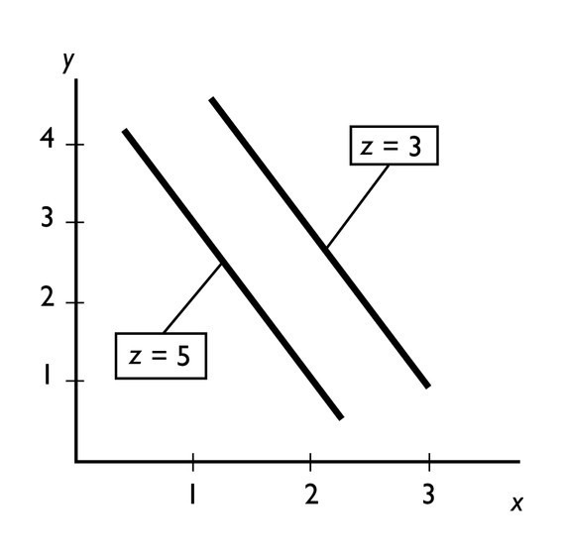
129) In the figure above, an increase in z leads to a
A) movement up along one of the lines showing the relationship between x and y.
B) movement down along one of the lines showing the relationship between x and y.
C) rightward shift of the line showing the relationship between x and y.
D) leftward shift of the line showing the relationship between x and y.
E) trend change in both x and y.
Answer: D
Topic: Relationships among more than two variables
Skill: Level 3: Using models
Section: Chapter 1 Appendix - Checkpoint 4
Status: Old
AACSB: Analytical thinking

130) In the figure above, ceteris paribus, an increase in x is associated with
A) an increase in y.
B) a decrease in y.
C) an increase in z.
D) a random change in z.
E) no change in either y or z.
Answer: B
Topic: Ceteris paribus
Skill: Level 2: Using definitions
Section: Chapter 1 Appendix - Checkpoint 4
Status: Old
AACSB: Analytical thinking
1.4 Integrative Questions

1) Suppose you decide to attend summer school and that this is considered a rational choice. When making this choice,
A) you must ignore the problem of scarcity.
B) you considered the marginal cost and marginal benefit of your choice.
C) you have used the ceteris paribus assumption.
D) you have made a positive statement.
E) you must have considered the social interest.
Answer: B
Topic: Integrative
Skill: Level 2: Using definitions
Section: Integrative
Status: Old
AACSB: Reflective thinking

2) John decides to leave college early and play professional sports. Which of the following economic principles does John use?
i. personal economic policies
ii. marginal cost versus marginal benefit analysis
iii. normative versus positive economics
A) i and ii
B) i, ii and iii
C) ii only
D) i and iii
E) ii and iii
Answer: A
Topic: Integrative
Skill: Level 2: Using definitions
Section: Integrative
Status: Old
AACSB: Reflective thinking

3) Which of the following is true?
i. A rational choice is always made in the pursuit of social interest.
ii. Economics is a social science.
iii. Economists try to understand how the economic world works by testing positive statements.
A) ii and iii
B) only i
C) only ii
D) only iii
E) i and ii
Answer: A
Topic: Integrative
Skill: Level 2: Using definitions
Section: Integrative
Status: Old
AACSB: Reflective thinking
4) Which of the following is true?
i. A rational choice is made on the margin.
ii. Microeconomics is the study of the national economy while macroeconomics is the study of the global economy.
iii. Economists try to understand how the economic world works by testing normative statements.
A) only i
B) i and iii
C) only ii
D) only iii
E) i and ii
Answer: A
Topic: Integrative
Skill: Level 2: Using definitions
Section: Integrative
Status: Old
AACSB: Reflective thinking

5) Will, Bill, and Phil decide to study an extra hour for an exam. Instead of studying, they could have gone out to eat, played football, or watched TV. Which of the following statements is correct?
A) The benefit the three students receive must be the same because they all make the same choice.
B) The students made a rational choice as long as they face no scarcity.
C) The students could each have different opportunity costs.
D) The marginal cost of the decision is the same if they make the same score on the exam.
E) Going out to eat, playing football, and watching TV are all called sunk costs.
Answer: C
Topic: Integrative
Skill: Level 2: Using definitions
Section: Integrative
Status: Old
AACSB: Reflective thinking

6) Which of the following is true regarding a normative statement?
i. It uses the ceteris paribus assumption.
ii. It is a value judgment.
iii. It accounts for opportunity costs.
A) i and iii
B) ii and iii
C) i only
D) ii only
E) i, ii, and iii
Answer: D
Topic: Integrative
Skill: Level 2: Using definitions
Section: Integrative
Status: Old
AACSB: Reflective thinking
7) To help unscramble cause and effect, economists
A) use the concept of opportunity costs.
B) must use the ceteris paribus assumption.
C) answer the "what" question.
D) answer the "how" question.
E) must use normative statements.
Answer: B
Topic: Integrative
Skill: Level 2: Using definitions
Section: Integrative
Status: Old
AACSB: Reflective thinking

8) Which of the following is true regarding this statement? "The president's decision to spend more money on national defense is smart."
A) This is a normative statement.
B) The federal government does not face scarcity.
C) This topic would be studied in microeconomics.
D) Social interest must always be more important than self-interest.
E) Ceteris paribus does not apply to the government.
Answer: A
Topic: Integrative
Skill: Level 2: Using definitions
Section: Integrative
Status: Old
AACSB: Reflective thinking

9) Gregory is considering attending a concert with a ticket price of $40. He estimates that the cost of driving to the concert and parking there will add an additional $20. In order to attend the concert, Gregory will have to take time off from his part-time job. He estimates that he will lose 5 hours at work, at a wage of $8 per hour. Gregory's opportunity cost of attending the concert equals
A) $80.
B) $100.
C) $40.
D) $60.
E) $20.
Answer: B
Topic: Integrative
Skill: Level 5: Critical thinking
Section: Integrative
Status: New
AACSB: Application of knowledge
10) Kevin is re-finishing an antique grandfather clock that he purchased at a flea market for $300. He expects to be able to sell the clock for $450. At the last minute, Kevin discovers that he needs to repair the gears at a cost of $175 to make the clock worth $450 to potential buyers. It turns out that he could also sell the clock now, without completing the additional repairs, for $250. What should Kevin do?
A) He should sell the clock now for $250.
B) He should keep the clock but not make the repairs since the original $300 is a sunk cost.
C) He should complete the additional repairs and sell the clock for $450.
D) He should keep the clock after making the repairs since it is not rational to spend a total of $475 on an item that can only be sold for $450.
E) Kevin is indifferent between selling the clock as is or selling it after completing the repairs.
Answer: C
Topic: Integrative
Skill: Level 5: Critical thinking
Section: Integrative
Status: New
AACSB: Application of knowledge

11) Which of the following scenarios describes an action that is not rational from an economic point of view?
A) After drinking one martini (shaken, not stirred), James buys and drinks a second martini even though the marginal benefit of the second martini is lower than the marginal benefit of the first.
B) Eric buys a replacement ticket to the basketball game after he realizes that he accidentally left his original ticket at home.
C) Emily chooses to attend a social event on Tuesday night instead of studying even though she has an important exam on Wednesday morning.
D) US Airways sells a last minute ticket to Don for $50 even though its average cost per passenger is $250.
E) None of the above
Answer: E
Topic: Integrative
Skill: Level 5: Critical thinking
Section: Integrative
Status: New
AACSB: Application of knowledge

12) Because resources are scarce, economists would say that
A) the best things in life are always free.
B) people's wants are unlimited.
C) every choice has an opportunity cost.
D) anything worth doing is worth doing well.
E) there are no benefits from cooperation.
Answer: C
Topic: Integrative
Skill: Level 5: Critical thinking
Section: Integrative
Status: New
AACSB: Reflective thinking
13) Wichita is building a convention center and financing it with revenues raised from a city hotel tax. Local politicians assert that the convention center is essentially free for Wichita residents because out-of-town visitors are paying for it. Someone who is practicing the economic way of thinking would disagree because
A) they believe that Wichita does not need a new convention center.
B) there are other projects that could be undertaken with the tax funds.
C) the convention center may not pass a marginal cost-benefit test.
D) the hotel tax may lead to a decline in visits to Wichita.
E) the hotel tax may reduce commercial property values in the area.
Answer: B
Topic: Integrative
Skill: Level 5: Critical thinking
Section: Integrative
Status: New
AACSB: Reflective thinking

14) Suppose that your public library charges a fixed monthly membership fee of $12. Members are allowed to check out as many books as they want under this plan. The average member checks out 4 books per month. Suppose that your public library changes its policy. Now each book costs $3 to check out but there is no longer a monthly membership fee. What effect do you think the new policy will have on the total number of books checked out from your library each month? The new policy is likely to ________ the number of booked checked out because ________.
A) leave unchanged; members have already shown that they are willing to pay $12 to check out 4 books per month
B) leave unchanged; the average cost of the library service is the same under both plans
C) reduce; the marginal benefit of checking out books is now lower under the new policy
D) reduce; the marginal cost of checking out books is now higher under the new policy
E) increase; the average benefit of checking out more than 4 books is now higher under the new policy
Answer: A
Topic: Integrative
Skill: Level 5: Critical thinking
Section: Integrative
Status: New
AACSB: Application of knowledge

15) In New York City, Mayor Michael Bloomberg has recently recommend that the city, with the help of private donors, make cash payments to poor and underprivileged parents who can certify that their children are attending school on a regular basis. The payments would start after third grade and go through high school, rising each year as dropout rates get higher and a child's forgone earning potential is higher. What economic concept does this policy represent?
A) public goods
B) technological progress
C) externalities
D) the "invisible hand"
E) incentives
Answer: E
Topic: Integrative
Skill: Level 5: Critical thinking
Section: Integrative
Status: New
AACSB: Reflective thinking
16) Nathan drinks three cups of coffee per day. The marginal benefit that he enjoys from drinking the third cup is
A) less than the marginal benefit that he receives from drinking the second cup.
B) the same as the total benefit from drinking all three cups minus the total benefit of drinking the first two cups.
C) both A and B.
D) greater than the marginal benefit that he receives from drinking the second cup.
E) none of the above.
Answer: C
Topic: Integrative
Skill: Level 5: Critical thinking
Section: Integrative
Status: New
AACSB: Reflective thinking

1.5 Chapter Figures

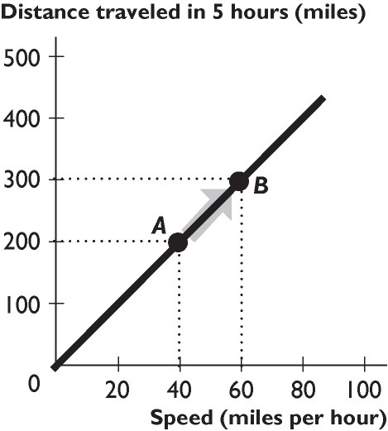

1) The relationship between distance traveled in 5 hours and speed shown in the figure above is
A) direct, linear.
B) inverse, linear.
C) direct, non-linear.
D) inverse, positive.
E) direct, negative.
Answer: A
Topic: Positive relationship
Skill: Level 2: Using definitions
Section: Chapter 1 Appendix - Checkpoint 3
Status: Old
AACSB: Analytical thinking
2) The relationship between distance traveled in five hours and speed shown in the figure above is
A) positive.
B) negative.
C) inverse.
D) cross-sectional.
E) multilateral.
Answer: A
Topic: Positive relationship
Skill: Level 2: Using definitions
Section: Chapter 1 Appendix - Checkpoint 3
Status: Old
AACSB: Analytical thinking

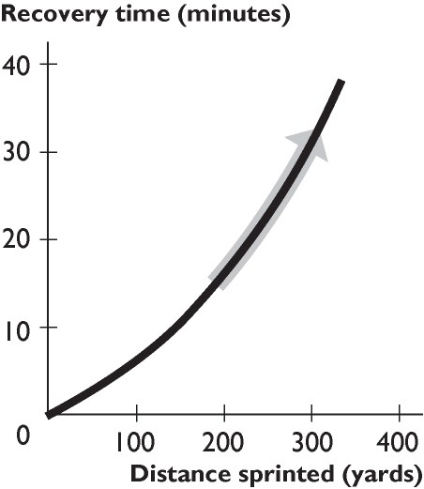

3) The figure above shows the relationship between distance sprinted and recovery time. The curve becomes steeper because as the distance sprinted increases,
A) the extra recovery time needed from sprinting another 100 yards increases.
B) the extra recovery time needed from sprinting another 100 yards decreases.
C) the recovery time increases.
D) the recovery time decreases.
E) the relationship between distance sprinted and recovery time becomes more inverse.
Answer: A
Topic: Positive relationship
Skill: Level 2: Using definitions
Section: Chapter 1 Appendix - Checkpoint 3
Status: Old
AACSB: Analytical thinking
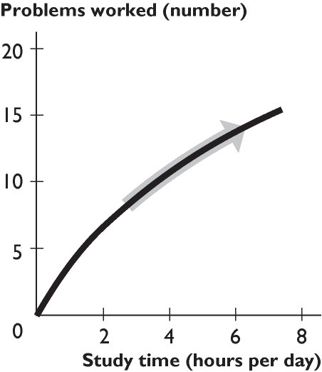

4) The figure above shows the relationship between study time and the number of problems worked. The curve becomes less steep because as you study more,
A) study time becomes less effective.
B) study time becomes more effective.
C) the number of problems worked increases.
D) the number of problems worked decreases.
E) the relationship between study time and the number of problems worked changes from direct to inverse.
Answer: A
Topic: Positive relationship
Skill: Level 2: Using definitions
Section: Chapter 1 Appendix - Checkpoint 3
Status: Old
AACSB: Analytical thinking
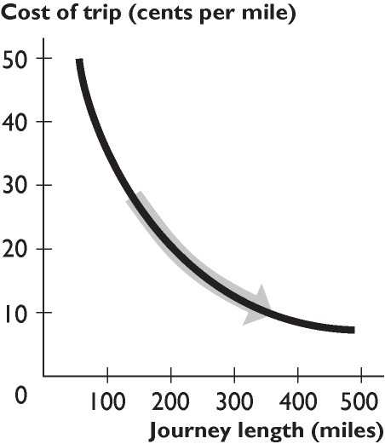

5) The figure above shows the relationship between the journey length and the cost of trip per mile. The curve becomes flatter because as the journey length increases,
A) the fall in the cost per mile becomes smaller.
B) the fall in the cost per mile becomes greater.
C) the cost per mile decreases.
D) the cost per mile increases.
E) the cost per mile remains unchanged.
Answer: A
Topic: Negative relationship
Skill: Level 2: Using definitions
Section: Chapter 1 Appendix - Checkpoint 3
Status: Old
AACSB: Analytical thinking
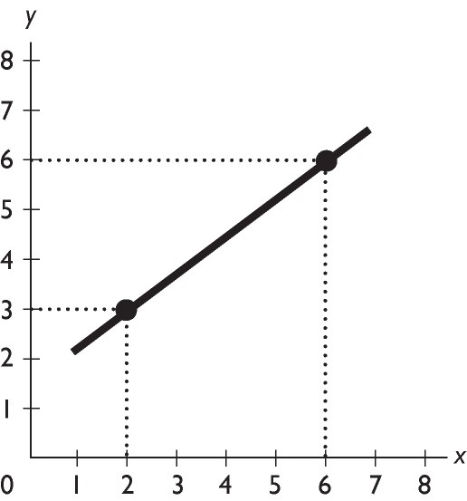

6) What is the slope of the line in the figure above?
A) 0.75
B) -0.75
C) 1.33
D) -1.33
E) zero
Answer: A
Topic: Slope
Skill: Level 3: Using models
Section: Chapter 1 Appendix - Checkpoint 3
Status: Old
AACSB: Analytical thinking
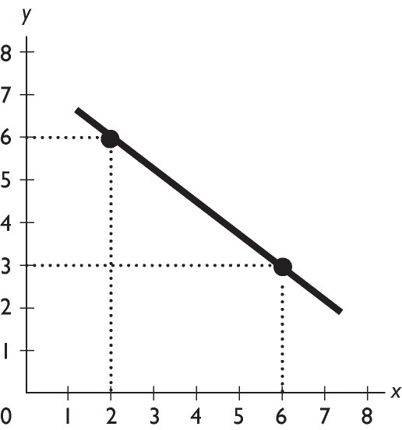

7) What is the slope of the line in the figure above?
A) 0.75
B) -0.75
C) 1.33
D) -1.33
E) zero
Answer: B
Topic: Slope
Skill: Level 3: Using models
Section: Chapter 1 Appendix - Checkpoint 3
Status: Old
AACSB: Analytical thinking
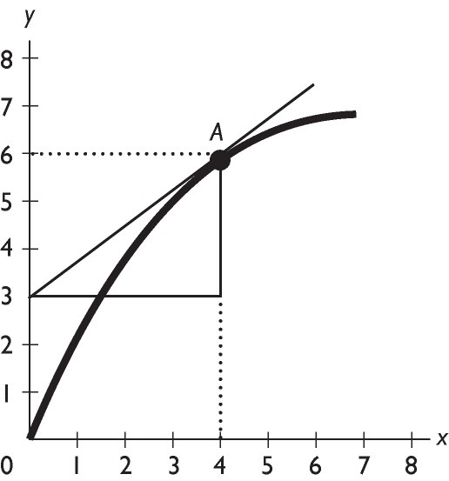

8) In the figure above, what is the slope of the curve at point A?
A) 0.75
B) -0.75
C) 1.33
D) -1.33
E) zero
Answer: B
Topic: Slope
Skill: Level 3: Using models
Section: Chapter 1 Appendix - Checkpoint 3
Status: Old
AACSB: Analytical thinking

1.6 Essay: Definition and Questions

1) What is the relationship between wants, resources, scarcity, and choices? Discuss the relationship for an individual and for a society.
Answer: A person faces scarcity whenever his or her wants exceed what he or she can obtain using his or her resources. Because the person cannot fulfill all of his or her wants, the person is forced to choose which wants will be satisfied and which wants will remain unsatisfied. The same results hold true for a society. All societies face scarcity because people's wants are essentially infinite, so that the resources available are not sufficient to fulfill everyone's wants. Because of this fact, societies must make choices about which (and whose) wants will be satisfied and which (and whose) wants will remain unsatisfied.
Topic: Scarcity
Skill: Level 2: Using definitions
Section: Checkpoint 1.1
Status: Old
AACSB: Written and oral communication
2) Why do economists say that even very rich people face scarcity?
Answer: A person faces scarcity whenever his or her wants exceed what he or she can obtain using his or her resources. Even very rich people want things that they cannot have. An older rich person, for instance, might want to have all of his or her youthful energy, but medical science cannot (yet) provide this service. Alternatively, another rich person might enjoy life so much that he or she wants 25 hours in a day in order to have more time for more enjoyment. But, such a want is impossible. By way of another, perhaps more realistic example, Malcolm Forbes was the founder of Forbes magazine and was very rich. However, he did not win every piece of art that he bid upon at auctions. Even though Mr. Forbes was very rich, he still passed on some art when the price got so high that he thought given his resources, the price exceeded what he was willing to pay. Mr. Forbes wanted the art, but he was not willing to bid higher in order to win it. Mr. Forbes faced scarcity.
Topic: Scarcity
Skill: Level 3: Using models
Section: Checkpoint 1.1
Status: Old
AACSB: Written and oral communication

3) What do economists mean when they discuss "scarcity"?
Answer: Scarcity occurs whenever people's wants exceed the ability of the available resources to meet these wants. Because people's wants are effectively infinite-it is always possible to imagine more good things to want to have-wants will always exceed what can be produced with the available resources, and so scarcity will always be present.
Topic: Scarcity
Skill: Level 2: Using definitions
Section: Checkpoint 1.1
Status: Old
AACSB: Written and oral communication

4) Define economics and describe its branches of study.
Answer: Economics is the social science that studies the choices made by individuals, businesses, government, and entire societies as they cope with scarcity. It has two branches, microeconomics and macroeconomics. Microeconomics is the study of the choices made by individuals and businesses, the way they interact, and the influence that governments exert on these choices. Macroeconomics is the study of the aggregate (total) effects on the national economy and the global economy of the choices that individuals, businesses, and governments make.
Topic: Definition of economics
Skill: Level 2: Using definitions
Section: Checkpoint 1.1
Status: Old
AACSB: Written and oral communication
5) Why does scarcity lead to the what, how, and for whom questions?
Answer: Human wants exceed the resources available to satisfy them, thereby creating the problem of scarcity of goods and services. Everyone wants more than he or she can have, be it a student dreaming of a faster computer or an extraordinarily rich business leader wishing for more vacation time. Because not all wants can be satisfied, people must make choices about which wants to satisfy. The choices resulting from scarcity mean that people must decide what gets produced, how are the products produced, and for whom are the products produced.
Topic: Scarcity and economic questions
Skill: Level 1: Definition
Section: Checkpoint 1.1
Status: Old
AACSB: Written and oral communication

6) List and explain the three fundamental economic questions that must be answered by all economic systems.
Answer: First, all economic systems must answer the question of "what goods and services get produced and in what quantities?" In other words, among the near infinite types of goods and services, society must decide what will be produced and how much of each good and service will be produced. Next, every economic system must decide, "how are goods and services produced?" This question needs to be answered because there are always many ways to produce a particular good or service (for instance, using a lot of workers and only a little machinery, or a lot of machinery and fewer workers), so the method that will be used must be decided. Finally, once the goods and services are produced the society must decide "for whom are the various goods and services produced?" In other words, societies must decide whether the goods and services are distributed so that everyone gets about the same amount or whether they are distributed so that some people get more than others.
Topic: Economic questions
Skill: Level 1: Definition
Section: Checkpoint 1.1
Status: Old
AACSB: Written and oral communication

7) Pumpkins are grown in New Mexico with the aid of fertilizer. Hence, fertilizer is a partial answer to which of the three economic questions?
Answer: Fertilizer is used to help produce the pumpkins, so it is a partial answer to the "How are goods and services produced?" question.
Topic: Economic questions, how
Skill: Level 3: Using models
Section: Checkpoint 1.1
Status: Old
AACSB: Reflective thinking
8) Different nations answer the what, how, and for whom questions differently. China, for instance, builds dams using many workers and only a little capital equipment. The United States builds dams using a few workers and a lot of capital equipment. Which economic question are these two nations answering and why do the answers differ?
Answer: The nations are answering the "how" question because they are determining how to produce a dam. In the main part, the answers differ because the nations have different amounts of capital equipment and labor. China has more people and less capital equipment. Hence it makes sense for China to build dams using many workers and only a little capital equipment. The U.S. has more capital equipment and less labor. Thus it makes sense for the United States to build dams using a lot of capital equipment and only a few workers.
Topic: Economic questions, how
Skill: Level 4: Applying models
Section: Checkpoint 1.1
Status: Old
AACSB: Written and oral communication

9) The question "Will doctors or lawyers have higher annual incomes?" represents which of the three basic economic questions?
Answer: The amount of goods and services a person can purchase depends on the person's income. Hence the question of who should be paid more, lawyers or doctors, essentially asks whether lawyers or doctors will be able to buy more goods and services. Thus the question is a microeconomic "For whom?" question.
Topic: Economic questions, for whom
Skill: Level 3: Using models
Section: Checkpoint 1.1
Status: Old
AACSB: Written and oral communication

1.7 Essay: The Economic Way of Thinking

1) What is the difference between microeconomics and macroeconomics?
Answer: Microeconomics studies the decisions of smaller economic actors, such as individual consumers or individual firms, and how the government can affect these decisions, say through how it regulates an industry. Macroeconomics studies the aggregate, or economy-wide, consequences of the decisions made by individuals and firms. Macroeconomics also studies the aggregate effects of government policies, such as the Federal Reserve's decisions to raise or lower interest rates.
Topic: Microeconomics and macroeconomics
Skill: Level 2: Using definitions
Section: Checkpoint 1.1
Status: Old
AACSB: Written and oral communication

2) What is an opportunity cost? Give an example.
Answer: An opportunity cost of something is the best thing you must give up to get it. For example, the cost of attending class might be the extra hour of sleep you lose, or the opportunity cost of buying a taco might be the soda you can no longer buy.
Topic: Opportunity cost
Skill: Level 1: Definition
Section: Checkpoint 1.2
Status: Old
AACSB: Written and oral communication
3) Your friend is preparing for this exam and in your practice session makes the following statement: "Instead of attending microeconomics class for two hours, Kiki could have played tennis or watched a movie. Therefore, the opportunity cost of attending class is the tennis and the movie she had to give up." Is your friend's analysis correct or not? Explain your answer.
Answer: Your friend's analysis is incorrect. The opportunity cost of an action is the (single) best thing she had to give up, not all the things she had to give up. Kiki's opportunity cost of studying for her exam is either the tennis or the movie, whichever she would have done had she not studied.
Topic: Opportunity cost
Skill: Level 3: Using models
Section: Checkpoint 1.2
Status: Old
AACSB: Written and oral communication

4) Rather than go out to eat by yourself, you decide to stay at home and fix dinner for yourself and your two roommates. Your roommates applaud your decision. Your roommates tell you that your decision to eat at home has no opportunity cost because you already have all the dinner ingredients in your pantry. Is this comment correct?
Answer: Your roommates' comment is incorrect. The opportunity cost of preparing dinner at home is whatever is the best thing you give up, which, given your choice boiled down to staying home or going out, is going out to eat. Hence the opportunity cost of fixing dinner at home is going out to eat.
Topic: Opportunity cost
Skill: Level 3: Using models
Section: Checkpoint 1.2
Status: Old
AACSB: Written and oral communication

5) Shaniq can spend the next hour studying for a finance test, hiking along the Oregon coast, watching reruns of Lost on television, or napping. If she decides to study, what is the opportunity cost of her choice: hiking, watching television, or napping?
Answer: With the information given, it is impossible to determine the opportunity cost. The opportunity cost is the highest-valued alternative forgone and the problem does not give Shaniq's ranking of the options. For instance, if Shaniq thinks that if she had not studied she would have watched Lost, then watching Lost is the opportunity cost. However, if Shaniq thinks that if she were not studying, she would be strolling along the beach, then the beach walk is the opportunity cost.
Topic: Opportunity cost
Skill: Level 3: Using models
Section: Checkpoint 1.2
Status: Old
AACSB: Written and oral communication
6) For spring break, Melanie will either stay home or go to Daytona Beach. At home, Melanie pays $10 per day for food and earns $90 a day at her job. At Daytona Beach, Melanie will stay with friends and so has no lodging cost. She will pay $20 per day for food. In terms of dollars, Melanie's opportunity cost per day of going to Daytona Beach is how much?
Answer: Melanie's opportunity cost of going to Daytona Beach is $100 per day. If she goes, she spends $10 extra for food and loses $90 income from her job, for a total opportunity cost of $100.
Topic: Opportunity cost
Skill: Level 3: Using models
Section: Checkpoint 1.2
Status: Old
AACSB: Reflective thinking

7) Why is the benefit of something measured by what you are willing to give up?
Answer: The benefit of a good or service, say a slice of pizza, is the pleasure it brings the consumer. But it is impossible to measure someone's pleasure. In order to measure the benefit of the slice of pizza, we need something that we can measure. Thus, to measure the benefit of the slice of pizza, we ask the consumer what he or she is willing to give up to get the slice of pizza. So, if the consumer was willing to give up, say, three hot dogs to get the slice of pizza, we can determine that the benefit of the slice of pizza to the consumer is three hot dogs.
Topic: Benefit
Skill: Level 2: Using definitions
Section: Checkpoint 1.2
Status: Old
AACSB: Written and oral communication

8) Define marginal cost and marginal benefit.
Answer: Marginal cost is the opportunity cost of a one-unit increase in an activity. Marginal benefit is the benefit of a one-unit increase in an activity.
Topic: Marginal benefit, marginal cost
Skill: Level 1: Definition
Section: Checkpoint 1.2
Status: Old
AACSB: Reflective thinking

9) In New State, the bottling law requires that people get a refund of five cents when they return an empty bottle or can. Why does the state pay people to return bottles? In your answer, be sure to mention the role played by rational choice.
Answer: Policy makers know that people making rational choices respond to incentives. Instead of throwing away bottles and cans, people will now bring the used bottles and cans to the designated areas for recycling in order to receive their payment. Thus policy makers have taken advantage of people's rational decision making in order to reduce litter and clean the environment.
Topic: Incentives
Skill: Level 3: Using models
Section: Checkpoint 1.2
Status: Old
AACSB: Written and oral communication
10) Must a rational choice always work out well? In other words, is it possible for someone to regret a rational decision?
Answer: It is not necessarily the case that a rational choice always works out well; sometimes people will come to regret a rational decision. Decisions are made based on the information at hand. Sometimes that information is incomplete. For instance, when faced with a math midterm on Thursday, on Wednesday night a student might believe that he or she has a strong grasp of the subject and hence rationally decide to go to a movie rather than study. When the test reveals that the student actually understood little about the math and the student earns a low score, he or she likely regrets not studying. But the regret does not imply that the decision to see the movie was irrational.
Topic: Making rational choices
Skill: Level 2: Using definitions
Section: Checkpoint 1.2
Status: Old
AACSB: Written and oral communication

11) Discuss what is necessary to make rational decisions. Be sure to mention opportunity cost, marginal cost, and marginal benefit.
Answer: Economists assume that people act rationally, making choices in increments and comparing marginal costs and benefits. Costs are measured as opportunity cost, which is the value of the best thing that must be given up. Benefits are subjective, measured by what you are willing to give up. Marginal cost is the additional cost of one more unit of the good and marginal benefit is the additional benefit of one more unit. Marginal cost increases and marginal benefit decreases as more of the activity is considered. A rational decision compares the marginal benefit of the decision to its marginal cost. If the marginal benefit exceeds the marginal cost, the (rational) decision is to undertake the action being contemplated. If the marginal benefit is less than the marginal cost, the (rational) decision is to not undertake the action being considered.
Topic: Making rational choices
Skill: Level 2: Using definitions
Section: Checkpoint 1.2
Status: Old
AACSB: Written and oral communication

12) What is a positive statement? Give an example.
Answer: A positive statement addresses "what is" and can be tested. An example of a positive statement is "An increase in the price of gasoline decreases the quantity of gasoline demanded."
Topic: Positive statements
Skill: Level 1: Definition
Section: Checkpoint 1.2
Status: Old
AACSB: Reflective thinking
13) What is the difference between positive and normative statements?
Answer: Positive statements tell what is and normative statements tell what ought to be. Positive statements can be tested to determine if they are correct or not, while normative statements use value judgments and so cannot be tested. For example, two economists might agree on the positive assertion that if the government spent its funds purchasing pharmaceutical drugs for poor older Americans rather than poor children, then poor older Americans would use more drugs and poor children would use fewer. But they might disagree on the normative conclusion of whether the government should pursue this policy. One economist might argue "It is not fair to have senior citizens suffer because they cannot afford medicine" and the other economist might argue "It is not fair to have children suffer because their parents cannot afford medicine."
Topic: Positive and normative statements
Skill: Level 2: Using definitions
Section: Checkpoint 1.2
Status: Old
AACSB: Written and oral communication

14) Two economists can agree that raising the minimum wage creates unemployment yet one might argue that raising the minimum wage is a good policy and the other that it is a bad policy. Why can this difference exist? Be sure to use the terms positive and normative in your answer.
Answer: Positive statements are statements that describe how the world is. Positive statements can be tested and so, ultimately, any disagreements about positive statements should be resolved. The statement that "Raising the minimum wage creates unemployment" is a positive statement and, on the basis of repeated testing, most economists agree that it is a correct positive statement. Normative statements, however, are statements that describe how the world ought to be. Normative statements depend on people's values and cannot be tested. So one economist might argue that raising the minimum wage is a good policy because this economist thinks that, although it is unfortunate that some people lose their jobs, the fact that others retain their jobs and their wages rise more than outweighs the harm created by the unemployment. Another economist might strongly differ because the second economist thinks that the harm inflicted on people who lose their jobs more than outweighs any good from some workers being paid more. This difference of opinion can last indefinitely because there is no way to test the two economists' beliefs to determine which is correct.
Topic: Positive and normative statements
Skill: Level 2: Using definitions
Section: Checkpoint 1.2
Status: Old
AACSB: Written and oral communication

15) Explain whether the statement, "There is life on Mars," is a normative or positive statement.
Answer: The statement is a positive statement because it does not depend on a value judgment. Instead, it is a statement that tries to describe "what is" and hence is testable. Of course, in order to test the assertion, it would be necessary to go to Mars to ascertain if there is life present. While it is difficult (!) at present to actually carry out the test, nonetheless the statement is testable and hence is a positive statement.
Topic: Positive statements
Skill: Level 2: Using definitions
Section: Checkpoint 1.2
Status: Old
AACSB: Written and oral communication
16) Explain whether the statement, "Hillary Clinton was elected President of the United States in 2008," is a normative or positive statement.
Answer: The statement is a positive statement because it does not depend on a value judgment. Instead, it is a statement that tries to describe "what is" and hence is testable. Now, it is indeed the case that Hillary Clinton was not elected president in 2008, so when we test the statement we discover that it is incorrect. But, whether the statement is correct or not has no bearing on whether the statement is positive or normative. Thus, the statement "Hillary Clinton was elected President in 2008" is a positive, albeit incorrect, statement.
Topic: Positive statements
Skill: Level 3: Using models
Section: Checkpoint 1.2
Status: Old
AACSB: Written and oral communication

17) What is a normative statement? Give an example.
Answer: A normative statement is a statement about what ought to be. It is a value judgment or opinion and so cannot be proven true or false. An example of a normative statement is "Students should attend school year round to receive a better education."
Topic: Normative statements
Skill: Level 1: Definition
Section: Checkpoint 1.2
Status: Old
AACSB: Reflective thinking

18) Explain whether the statement "The government should increase tariffs on Japanese cars to protect the American car industry from competition," is a normative or positive statement.
Answer: The statement is normative. The statement is a normative statement because it depends on a value judgment, namely that the government should protect the American car industry from competition.
Topic: Normative statements
Skill: Level 2: Using definitions
Section: Checkpoint 1.2
Status: Old
AACSB: Reflective thinking

1.8 Essay: Appendix: Making and Using Graphs

1) Why do economists use graphs?
Answer: Graphs help economists, and others, to visualize the relationships between economic variables. Graphs that plot variables together help economists understand if the variables are related and how they are related. Graphs also help provide a visual picture of economic models that link different variables. Indeed, many other disciplines use such visual models. For example, architects work with blueprints (their model) and the blueprints represent every detail of a building. Economists' models do not reflect of every detail of the real world, but the graphs that they use nonetheless are valuable because they help clarify the linkages between the variables.
Topic: Basic idea
Skill: Level 2: Using definitions
Section: Chapter 1 Appendix - Checkpoint 1
Status: Old
AACSB: Analytical thinking
2) What kind of information is conveyed in a time-series graph?
Answer: A time series graph reveals four types of information. First, it shows the actual value of the variable or variables at each point in time. Second, it shows whether the variable or variables are rising or falling as time passes. Third, it shows the speed with which the variable or variables are changing. Finally, it shows the presence or absence of a trend.
Topic: Time-series graph
Skill: Level 2: Using definitions
Section: Chapter 1 Appendix - Checkpoint 1
Status: Old
AACSB: Analytical thinking

3) In the diagram below, label the x-axis, the y-axis, and the origin.
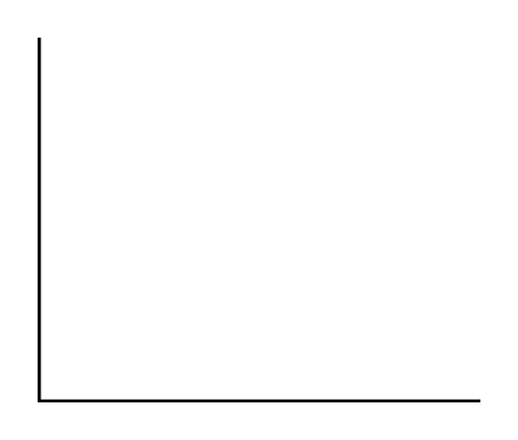
Answer:
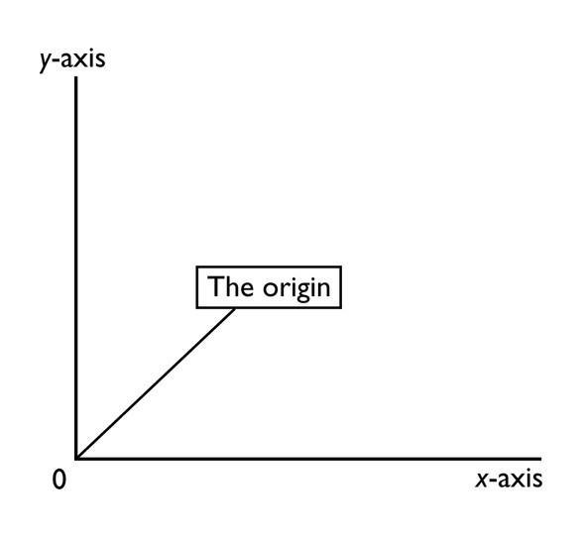
The figure above has the x-axis, the y-axis, and the origin labeled.
Topic: Basic idea
Skill: Level 1: Definition
Section: Chapter 1 Appendix - Checkpoint 1
Status: Old
AACSB: Analytical thinking
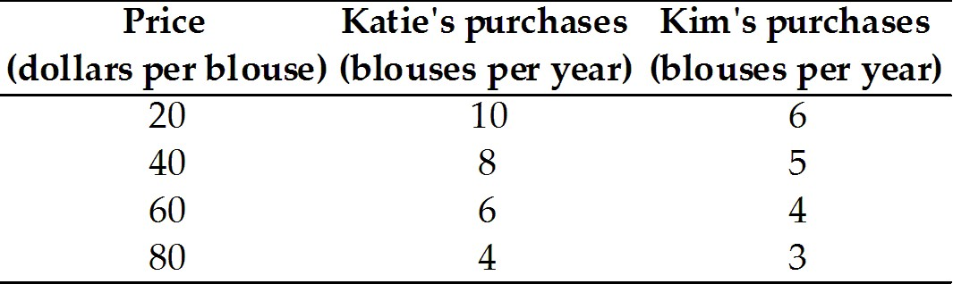

4) The table above shows how many blouses Katie and Kim will purchase at different prices for a blouse. In the figure, label the axes and put the price on the y-axis and the quantity of blouses on the x-axis. Plot the data for Katie in the figure. Then, plot the data for Kim in the figure.
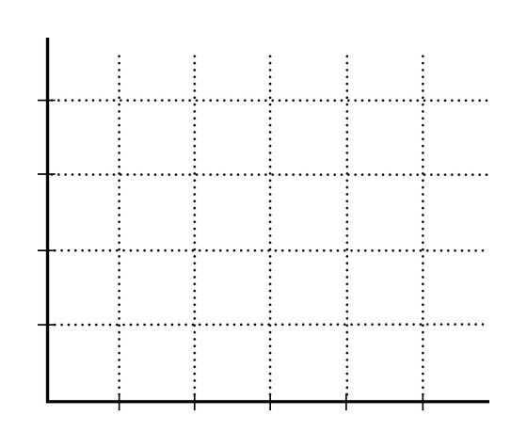
Answer:
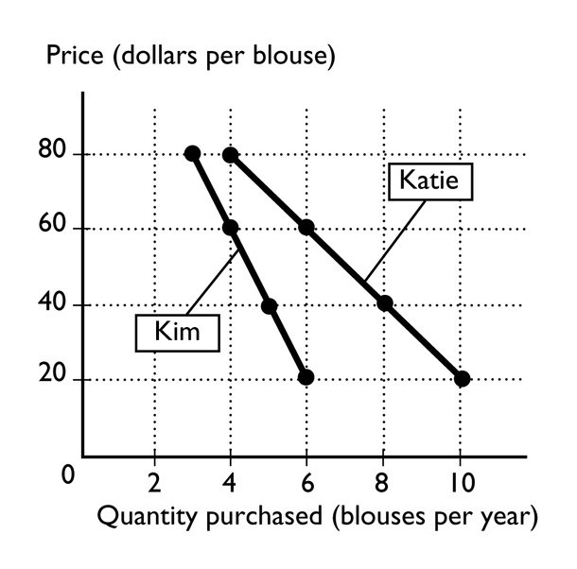
The figure above shows the labeled axes and has drawn in it the relationships between the price and the quantity of blouses purchased for Katie and Kim.
Topic: Scatter diagrams
Skill: Level 1: Definition
Section: Chapter 1 Appendix - Checkpoint 1
Status: Old
AACSB: Analytical thinking
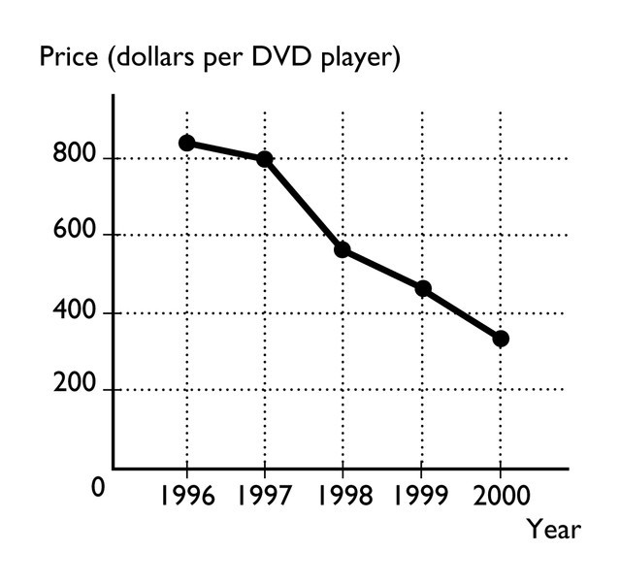

5) The figure above shows the price of a DVD player from 1996 to 2000.
a. What type of graph is illustrated above?
b. What is the trend in the price of a DVD player?
Answer:
a. The graph is a time-series graph because it plots time along the horizontal axis and the price of a DVD player along the vertical axis.
b. The trend in the price of a DVD player is negative, that is, the price of a DVD player has generally decreased from one year to the next.
Topic: Time-series graph
Skill: Level 1: Definition
Section: Chapter 1 Appendix - Checkpoint 1
Status: Old
AACSB: Analytical thinking

6) What are the two different types of relationships that variables can have? Explain each. What do these relationships look like when they are graphed?
Answer: Variables can have two relationships: positive (or direct) and negative (or inverse). A positive relationship occurs when the variables move in the same direction, so that when one increases, the other also increases. A negative relationship occurs when the variables move in the opposite direction, so that when one increases, the other decreases. When a positive relationship is graphed, the line slopes upward to the right. When a negative relationship is graphed, the line slopes downward to the right.
Topic: Relationships
Skill: Level 1: Definition
Section: Chapter 1 Appendix - Checkpoint 2
Status: Old
AACSB: Analytical thinking
7) What is the difference between a positive and a negative relationship?
Answer: Two variables are positively related when an increase (decrease) in one is associated with an increase (decrease) in the other. In this case, the variables move together, in the same direction. Two variables are negatively related when an increase (decrease) in one is associated with a decrease (increase) in the other. In this case, the variables move in the opposite direction.
Topic: Relationships
Skill: Level 1: Definition
Section: Chapter 1 Appendix - Checkpoint 2
Status: Old
AACSB: Analytical thinking

8) A graph of two variables is a vertical line. What is the interpretation of this result?
Answer: When the graph of two variables is a vertical line, the variables are not related because, with this graph, whenever the variable measured along the vertical axis changes, the variable measured along the horizontal axis does not change.
Topic: Unrelated variables
Skill: Level 1: Definition
Section: Chapter 1 Appendix - Checkpoint 2
Status: Old
AACSB: Analytical thinking

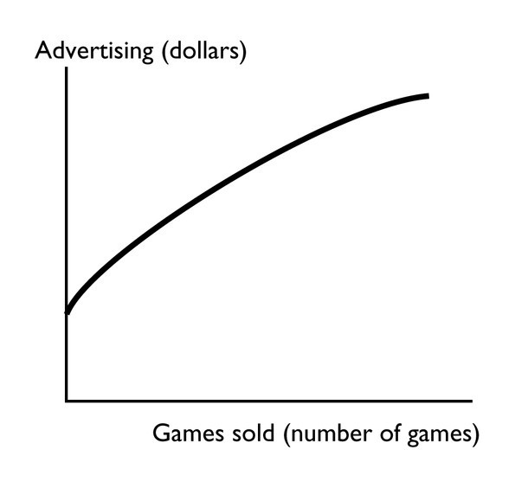

9) The figure above shows how the sales of the video game "Tomb Raider—Lara Retires" change when the advertising spent on the game changes. Is the relationship between advertising and the number of games sold positive, negative, or neither? Explain your answer.
Answer: The figure shows that there is a positive relationship between advertising and the number of video games sold. The relationship is positive because the two variables move together: If advertising increases, so, too, does the number of games sold.
Topic: Positive relationship
Skill: Level 2: Using definitions
Section: Chapter 1 Appendix - Checkpoint 2
Status: Old
AACSB: Analytical thinking
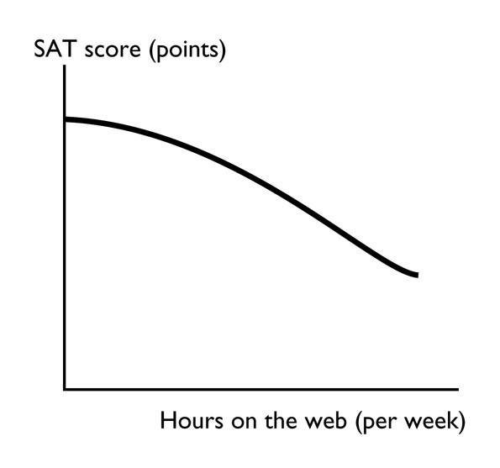

10) The figure above shows how the relationship between the number of hours per week a high school student spends on the web and the student's SAT score. Is the relationship between hours on the web and the SAT score positive, negative, neither? Explain your answer.
Answer: The figure shows that there is a negative relationship between hours on the web and the student's SAT score. The relationship is negative because the two variables move in opposite directions: If hours on the web increase, the SAT score decreases.
Topic: Negative relationship
Skill: Level 2: Using definitions
Section: Chapter 1 Appendix - Checkpoint 2
Status: Old
AACSB: Analytical thinking
11) A graph has a point that is either a maximum or a minimum. To the left of the point, the slope of relationship is positive. To the right of the point, the slope is negative. Is the point a maximum point or a minimum point? Be sure to draw a figure that supports your answer.
Answer:
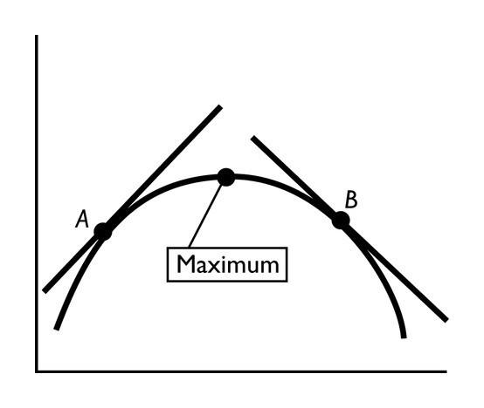
The point is a maximum point. Examine the figure above. The slope of a curved line at any point equals the slope of a straight line that touches the curved line at only that one point. Thus to the left of the maximum point, take point A. The slope of the straight line that touches the curved line at only point A is positive, so the slope of the relationship is positive. Similarly, take point B to the right of the maximum point. As the straight line shows, the slope of the relationship at point B is negative. Indeed, whenever there is a maximum point, the slope of the relationship to the left of the maximum is positive and the slope to the right is negative.
Topic: Maximum
Skill: Level 1: Definition
Section: Chapter 1 Appendix - Checkpoint 2
Status: Old
AACSB: Analytical thinking

12) What does the slope of a straight line equal? How is the slope of a curved line calculated?
Answer: The slope of a straight line is calculated between two points on the line. Between the two points on the line, the slope equals the change in the value of the variable measured on the vertical axis (the y-axis) divided by the change in the value of the variable measured on the horizontal axis (the x-axis). The slope of a curved line is calculated at a point on the line. At that point on the curved line, draw a straight line that touches the curved line at only that point. Then, calculate the slope of the straight line. The slope of the curved line at that point equals the slope of the straight line.
Topic: Slope
Skill: Level 1: Definition
Section: Chapter 1 Appendix - Checkpoint 3
Status: Old
AACSB: Analytical thinking
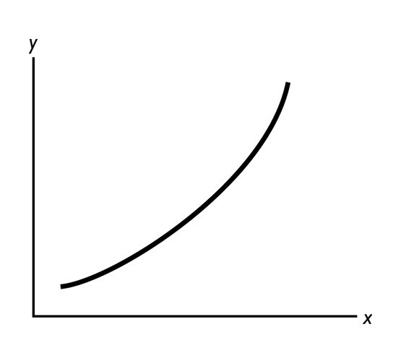

13) In the figure above, what can you deduce about the slope of the curve?
Answer: The slope is positive and increasing in size as we move rightward along the curve.
Topic: Slope
Skill: Level 2: Using definitions
Section: Chapter 1 Appendix - Checkpoint 3
Status: Old
AACSB: Analytical thinking

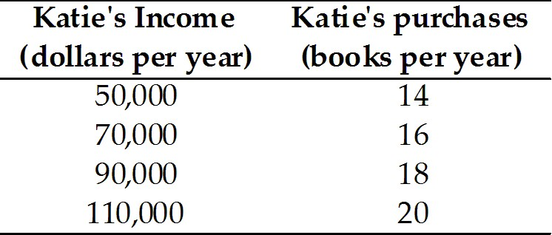

14) The table above shows how the number of books Katie buys each year depends on her income
a. What kind of relationship exists between Katie's income and the number of books she purchases?
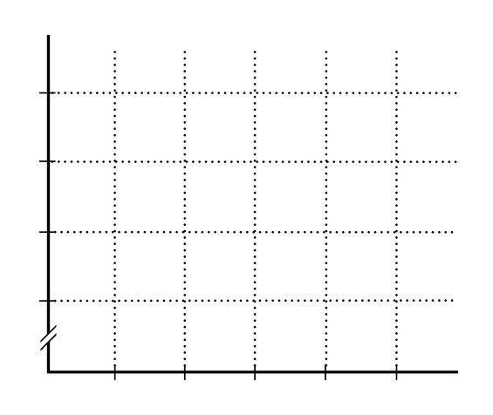
b. Plot the relationship between Katie's income and the number of books she purchases in the above figure. Measure income along the vertical axis and the number of books along the horizontal axis. Be sure to label the axes.
c. What is the slope of the relationship between $50,000 and $70,000 of income?
d. What is the slope of the relationship between $90,000 and $110,000 of income?
e. Comment on the similarity or dissimilarity of your answers to parts (c) and (d).
Answer:
a. There is a positive relationship. When Katie's income increases, so too does her purchase of books.
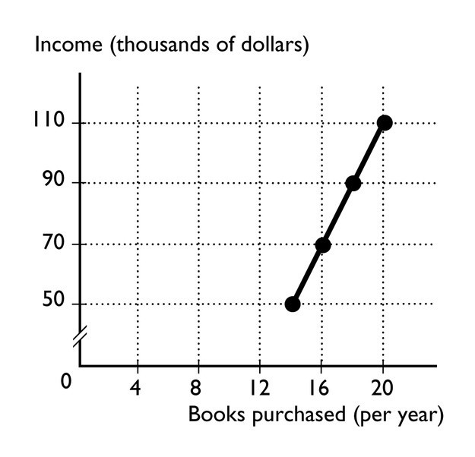
b. The relationship is plotted in the figure above.
c. The slope equals the change in the value of the variable measured on the vertical axis, income, divided by the change in the value of the variable measured along the horizontal axis, the number of books. Between $50,000 and $70,000 of income, the number of books purchased increases from 14 to 16. Hence income increases by $20,000 and the number of books increases by 2, so the slope equals $20,000/2 = 10,000.
d. As with the previous answer, the slope equals the change in income divided by the change in books. Between $90,000 and $110,000 of income, the number of books purchased increases from 18 to 20. Hence income increases by $20,000 and the number of books increases by 2, so the slope equals $20,000/2 = 10,000.
e. The slopes in parts (c) and (d) are equal. But, they must be equal because the relationship between Katie's income and the number of books she purchases is linear. For a linear relationship, the slope is the same regardless of where it is measured.
Topic: Slope
Skill: Level 3: Using models
Section: Chapter 1 Appendix - Checkpoint 3
Status: Old
AACSB: Analytical thinking

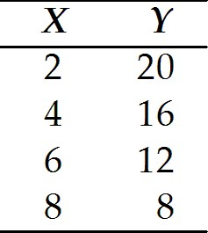

15) Graph the data in the table above in the figure. Label the axes.
a. Is the relationship between X and Y positive or negative?
b. What is the slope when X = 4?
c. What is the slope when X = 8?
Answer:
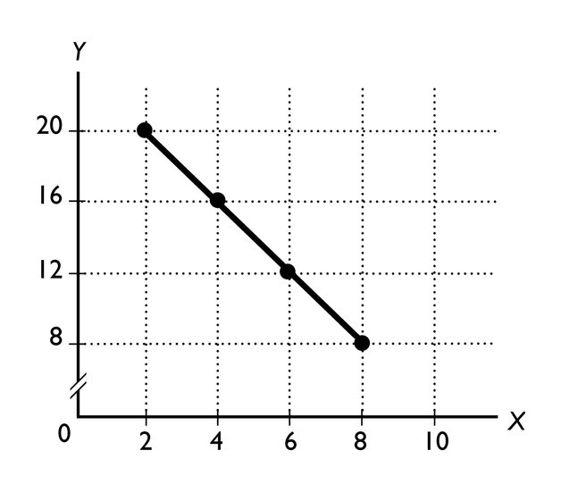
The figure labels the axes and graphs the relationship.
a. The relationship between X and Y is negative.
b. The slope equals -2.
c. The slope equals -2.
Topic: Slope
Skill: Level 2: Using definitions
Section: Chapter 1 Appendix - Checkpoint 3
Status: Old
AACSB: Analytical thinking
16) In the diagram below, draw a straight line with a slope of zero.
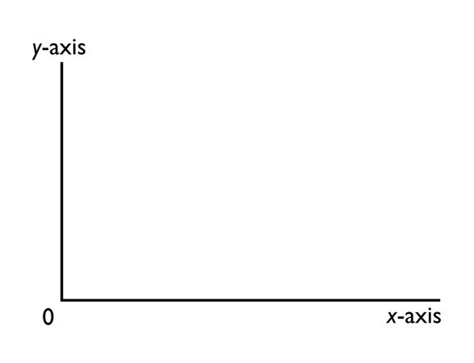
Answer:
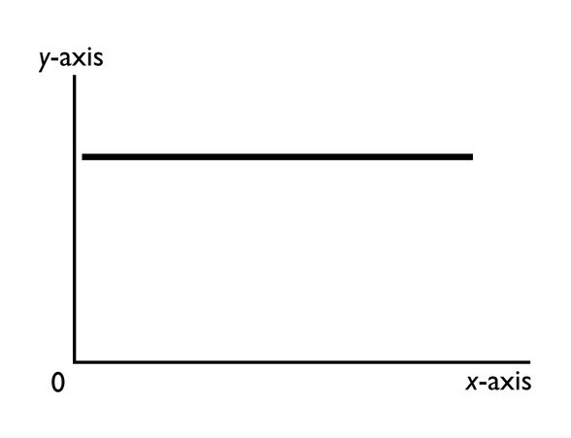
A horizontal line has a slope of zero. The figure above shows a horizontal line with a slope of zero.
Topic: Slope of a straight line
Skill: Level 2: Using definitions
Section: Chapter 1 Appendix - Checkpoint 3
Status: Old
AACSB: Analytical thinking
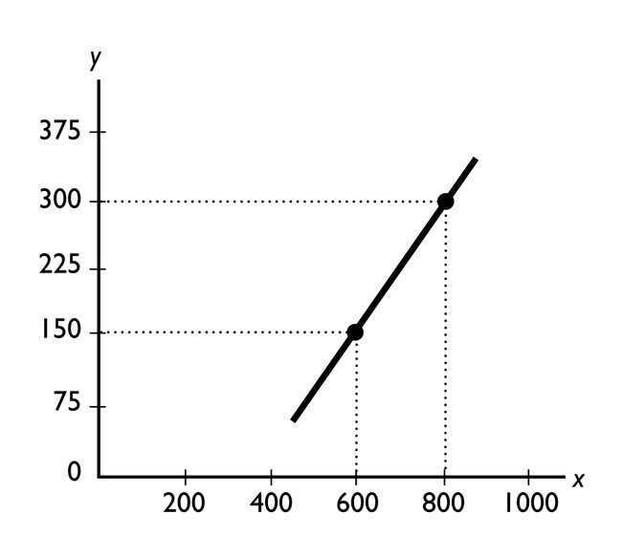

17) What does the slope of the line shown in the above figure equal?
Answer: The slope equals the change in variable on the y-axis divided by the change in the variable on the x-axis, or 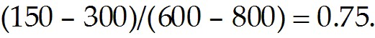
Topic: Slope of a straight line
Skill: Level 3: Using models
Section: Chapter 1 Appendix - Checkpoint 3
Status: Old
AACSB: Analytical thinking
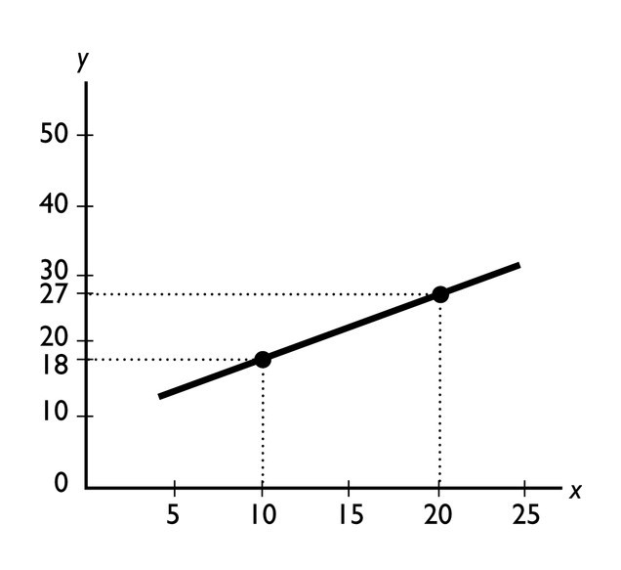
18) What does the slope of the line shown in the above figure equal?
Answer: The slope equals the change in variable on the y-axis divided by the change in the variable on the x-axis, or 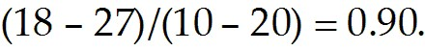
Topic: Slope of a straight line
Skill: Level 3: Using models
Section: Chapter 1 Appendix - Checkpoint 3
Status: Old
AACSB: Analytical thinking
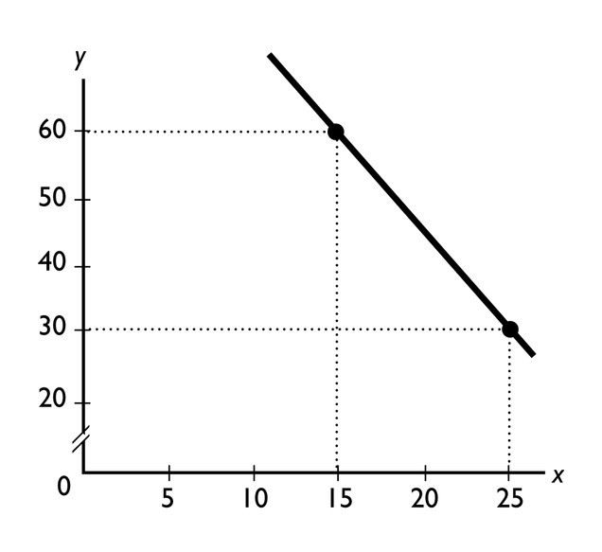
19) What does the slope of the line shown in the above figure equal?
Answer: The slope equals the change in variable on the y-axis divided by the change in the variable on the x-axis, or 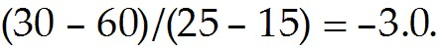
Topic: Slope of a straight line
Skill: Level 3: Using models
Section: Chapter 1 Appendix - Checkpoint 3
Status: Old
AACSB: Analytical thinking

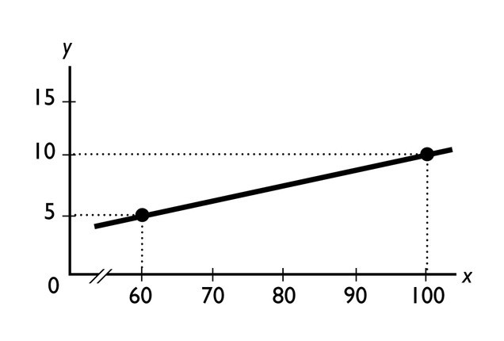
20) What does the slope of the line shown in the above figure equal?
Answer: The slope equals the change in variable on the y-axis divided by the change in the variable on the x-axis, or 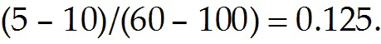
Topic: Slope of a straight line
Skill: Level 3: Using models
Section: Chapter 1 Appendix - Checkpoint 3
Status: Old
AACSB: Analytical thinking
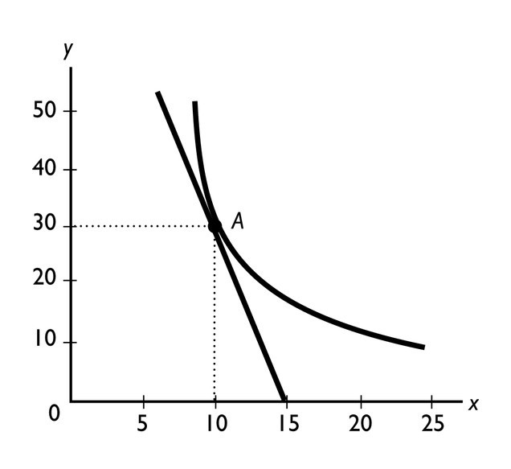
21) What does the slope of the curved line at point A shown in the above figure equal?
Answer: The slope of a curved line equals the slope of a straight line that touches the curved line at only that point. And, the slope of a straight line equals the change in variable on the y-axis divided by the change in the variable on the x-axis. Measure the slope of the straight line from point A to where the line crosses the x-axis, at 15. Thus the straight line has a slope of 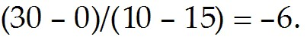Therefore the curve line at point A also has a slope equal to -6.
Topic: Slope
Skill: Level 3: Using models
Section: Chapter 1 Appendix - Checkpoint 3
Status: Old
AACSB: Analytical thinking

22) "It is impossible to represent a three variable relationship in a two-dimensional graph." Is this statement true or false? Explain your answer.
Answer: The statement is false because it is possible to represent a three variable relationship in a two dimensional graph. To do so, start by focusing on two of the variables. Assume that the third variable does not change (the ceteris paribus assumption) and then graph the relationship between the two variables. The graph shows how these two variables are related when the third variable does not change. When the third variable does change, then the entire relationship between the two graphed variables changes. In other words, the line showing the relationship between the two graphed variables shifts so that it becomes an entirely new line. The shift in the line shows how the third variable influences the other two.
Topic: Relationships among more than two variables
Skill: Level 2: Using definitions
Section: Chapter 1 Appendix - Checkpoint 4
Status: Old
AACSB: Analytical thinking
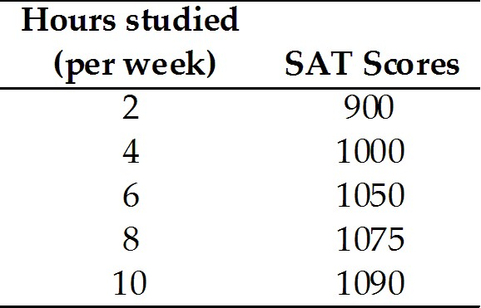

23) Jamie is preparing to take his SAT tests. The table above shows how Jamie's score depends on the number of hours a week Jamie studies
a. Plot the relationship in the figure, putting the hours studied on the horizontal axis.
b. Is the relationship you plotted positive or negative?
c. What happens to the slope of the relationship as hours studied increase?
d. Suppose Jamie can enroll in an SAT prep course and, by so doing, for every possible number of hours he studies, his score will be 100 points higher. Plot the new relationship between the number of hours studied and Jamie's SAT score in the figure.
e. How many variables are involved in the figure you just completed?
Answer:
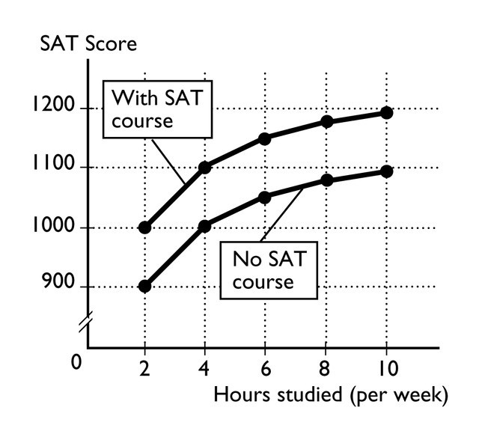
a. The figure above plots the relationship between the number of hours Jamie studies and his SAT score.
b. The relationship is positive: As Jamie increases the hours he studies, his SAT score increases.
c. The relationship is nonlinear, so the slope of the relationship changes as the number of hours studied changes. In the figure, the slope of the relationship decreases in size as the number of hours studied increases.
d. The figure above also plots the relationship between the hours Jamie studies and his SAT score if Jamie takes an SAT preparation course.
e. There are three variables: The number of hours Jamie studies, whether or not he takes an SAT preparation course, and his SAT score.
Topic: Relationships among more than two variables
Skill: Level 3: Using models
Section: Chapter 1 Appendix - Checkpoint 4
Status: Old
AACSB: Analytical thinking

